**National Curriculum 2023**

**Mathematics Curriculum Guide**

**Table of Content**

Introduction to the Guide 2

Shifting from Unproductive to Productive Mathematics Classrooms 2

Teaching Practices 4

Assessment Practices 9

Types of Assessments 10

Rubrics and Grading 12

Formative Assessment Plan 13

Curriculum Unit Breakdown 15

Grade 9-10 15

Grade 11-12 36

Appendix 71

References 76

## Introduction to the Guide

The purpose of this teacher guide is to fill the gap between the development and adoption of the National Curriculum 2023 for Mathematics. It is designed by the National Curriculum Council to help high school teachers implement the newly designed 2023 National Curriculum in their mathematics classrooms. This guide will introduce them to effective mathematics teaching practices and beliefs that can lead to greater student learning along with examples of activities and assessments that can help achieve this.

The primary focus of this teacher guide is to equip teachers with the knowledge and tools needed to shift from “unproductive” mathematics classrooms where students sit in rows, silently watching the teacher solve questions while copying notes from the board and doing a series of repetitive practice problems, to “productive” student-centered classrooms where the teacher acts as a facilitator and students sit in small groups, engaging in productive mathematical discussions. Active approaches of teaching and learning not only allow students to see the true nature of mathematics where reason and thought are critical, but also help students increase their understanding of mathematical concepts.

## Shifting from Unproductive to Productive Mathematics Classrooms

Our aim for the Mathematics National Curriculum 2023 is to develop five learning strands in students that constitute the learning of mathematics:

1. *Conceptual understanding:* comprehending and relating mathematical concepts, operations, and relationships.
2. *Procedural fluency:* effectively and efficiently utilizing procedures to solve problems.
3. *Strategic competence:* formulating, expressing and solving mathematical problems
4. *Adaptive reasoning:* thinking logically and justifying one's reasoning.
5. *Productive disposition:* viewing Mathematics as meaningful, worthwhile, and achievable through effort and hard work, and having a positive self-image as a competent learner and doer of mathematics.

In order to achieve this high level of mathematical learning, we need to provide students with rich opportunities and experiences within the mathematics classrooms. This includes:

* Involving students in demanding activities that require active comprehension and foster meaningful learning.
* Linking new information with prior knowledge and informal reasoning, and addressing any misunderstandings.
* Promoting the understanding of concepts as well as procedures, so students can effectively categorize their knowledge, learn new information, and apply it to new situations.
* Fostering a social learning environment through discourse, activities, and interaction while working on meaningful problems.
* Providing timely and detailed feedback to students, allowing them to reflect and improve their work, thoughts, and understanding.
* Enhancing students' self-awareness as learners, thinkers, and problem-solvers and teaching them to monitor their learning and performance.

The role of the teacher is very crucial in shifting our mathematics classrooms from silent, teacher-led classrooms to active, student-led classrooms where the above experiences are taking place. It is critical for teachers to understand the importance of this change and believe in their abilities to help implement this change.

Currently, most of our students go through silent math classrooms that make them view mathematics as a difficult and boring subject. The lack of feedback from the teacher and other students, and the chase to get to the right answer, forces the students to see mathematics as a subject where there is no room for analysis, reason, and inquiry. On the contrary, mathematicians have argued with one another over what is right or wrong, instead of accepting the ideas as presented to them. Coming to conclusions through reasoning and justifying one’s work to others is what mathematicians engage in and doing so makes one realize that mathematics is not about a set of rules that one can memorize, but instead it is a subject that is open to interpretation, new ideas and thoughts. We need to work towards this idea and build classrooms that encourage students to act and think like mathematicians, and that give space for students to demonstrate their thinking.

In addition to helping students experience the true essence of mathematics, student-centered classrooms where students are engaged in discussions, help them reach a deeper understanding of mathematical ideas. Students have a false perception that they can understand math by only listening to the teacher talk about it while the actual understanding lies in talking to others about it, explaining their ideas and discussing different methods. Students are a great resource in the classroom too, and it is important for them to see each other as sources of knowledge. An example of this student-driven approach to teaching can be seen in Japanese classrooms where collaborative work is highly encouraged, and both the students and teachers are positioned as knowledge givers and sources of support. We need to have classrooms where students see themselves as mathematicians, and not be bound by ideas that math is only for the smart or only for the boys. They should not only see themselves as capable of doing mathematics, but also those around them, and to have them learn from each other and help each other grow.

The table below highlights the true role of a teacher and student in classrooms by summarizing the unproductive and productive beliefs regarding the teaching and learning of mathematics.

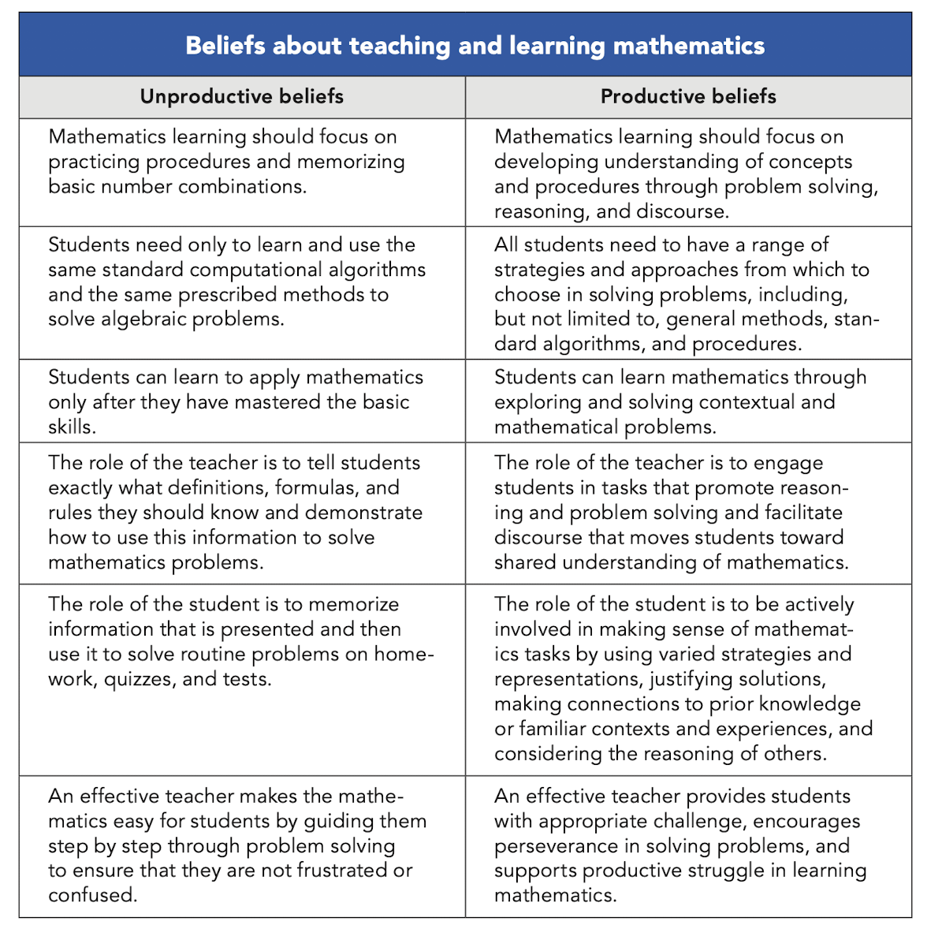Taken from NCTM (2014)

## Teaching Practices

To facilitate teachers to move towards this shift in mathematics teaching and learning, the table below highlights eight effective research-informed teaching practices:

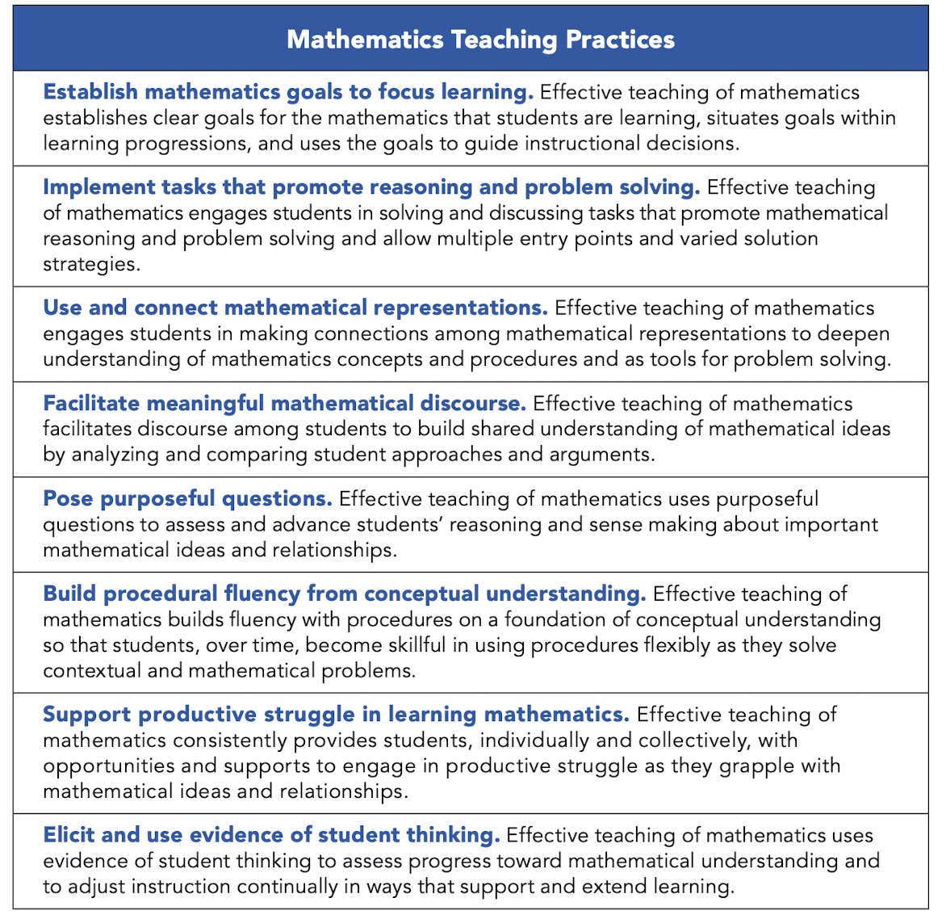Taken from NCTM (2014)

To help understand and demonstrate these teaching practices, the teachers can follow the below teaching cycle, which links the teaching practices to the National Curriculum designed for Mathematics:

1. **Establish goals**

One of the key steps to planning a lesson is deciding on what you want the students to learn from that particular lesson. For this, it is important to know where the lesson sits in the overall curriculum and how it connects with the other units. The teachers should make themselves familiar with the Cross-cutting themes, standards, benchmarks and Student Learning Outcomes to help them establish their specific lesson goals. To help teachers get started, some of the topics have been further broken down into smaller, more achievable goals in the knowledge, skills and perspectives section in the Curriculum guide. For e.g., in the functions unit, an intended procedural outcome is, *“Identify examples and nonexamples of functions,”* which accompanies the conceptual outcome of *“Functions are single-valued mappings from the domain to the range.”* These lesson goals can be used as the foundation for the lesson where the launch of the lesson, main activities involving problem-solving tasks and discussions, and the wrap-up of the lesson are all designed to achieve the intended goal.

1. **Select/design great tasks**

Students should be engaged in solving challenging mathematical tasks that help them discover and connect with mathematical ideas, instead of questions that require students to memorize formulas and routinely apply standard algorithms. The different levels of demand along with sample tasks can be found in the Appendix. These can be used as guidance to help teachers design and select tasks that are high in cognitive demand.

The curriculum guide has examples of learning activities that are group-worthy and cognitively demanding. These tasks will push students to make connections between different representations and strategies, justify their work through reasoning, build on their previous knowledge, and engage in productive struggle. Good problem solving tasks are also “low floor, high ceiling”, meaning that they are easily accessible for all kinds of learners as they allow multiple entry points, yet lead to rich mathematical ideas which help spur student curiosity and interest.

Teachers should also select tasks that will highlight at least one aspect of the nature of mathematics, including its connections with the other disciplines, as outlined in the Cross-cutting themes. They should provide students with the opportunity to reflect on their views of Nature of Mathematics within a unit, highlight any particular aspect that naturally comes up during the teaching activities, and then at the end of a unit, provide students the opportunity to reflect on and refine their views on the Nature of Mathematics. Teachers can take help from the sample learning activities presented in this guide that incorporate the nature of mathematics.

It is important to realize that all fun-based activities or real-world connections might not be appropriate if the tasks are not leading to the learning of some important mathematical idea. The teachers should solve the selected tasks themselves to see the potential big ideas they would want to highlight that connect with their intended lesson goals. They should make predictions about the different ways students may solve and struggle. This will help them come up with questions they could pose during the class that will support group thinking and collaboration.

1. **Facilitate student discussion**

Once the students are assigned tasks, they should be encouraged to discuss with their group and seek each others’ support. To have effective group discussions, it is important for a teacher to set norms in the classroom where every voice is heard, and students respect and value each other.

As the students are engaged in problem-solving and discussion, the teacher can act as a facilitator, listen to math talk, and observe emerging strategies. Teachers should make sure that they allow the students to attempt the task themselves and learn through their mistakes. Guiding the student through every step of the problem or telling them the answers will not allow the students to develop a deep understanding of the topic. Instead, questions can be posed that guide them to think critically and provide justification for their work. A monitoring sheet can be used to note down the different strategies students are coming up with and select some student work that can be presented to the whole class for a reflective discussion.

1. **Connect mathematical ideas**

After students are done with solving the problem, or as appropriate, teachers can bring the whole class together for a discussion. The selected students can be asked to present their strategies and/or solutions. The mathematical content of the shared work should be sequenced in a way that connects different representations and ideas together. Some of the connections that can be made between different representations are highlighted by this diagram:

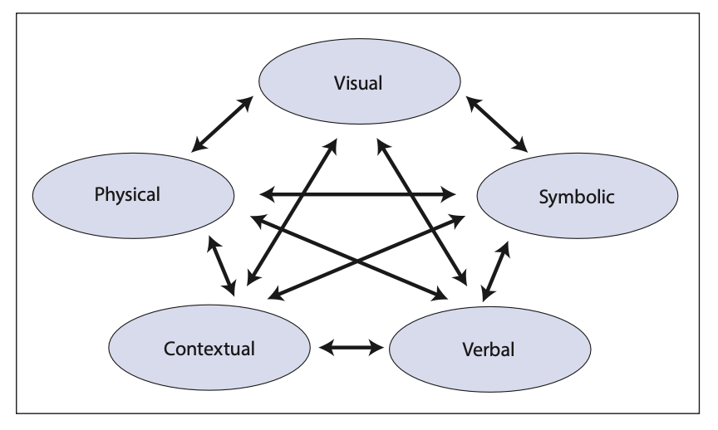  
Taken from NCTM (2014)

The discussion should also tie back to the lesson goals, help students build conceptual understanding from procedural fluency, and spark curiosity, intrigue, and interest in them.

1. **Reflect and adapt**

Once the lesson is over, teachers should take out some time to reflect on what went well, what could have gone better, and what were some of the challenges that they faced. They should also reflect on the student responses and feedback to assess student understanding and tailor content for the next lessons. Particular strategies for formative assessment that allow this kind of feedback cycle are discussed in the Assessment Practices below.

**On Use of Educational Mathematics Softwares:**

Use of educational mathematics software (such as Desmos, Maple and GeoGebra) is encouraged, but not compulsory. This is keeping in line with international best practices regarding flexible and dynamic teaching approaches.

## Assessment Practices

Assessments are an important part of the teaching and learning cycle. However, usually assessments are only focused on measuring student achievement, instead of also acting as a means of feedback to improve teaching and learning. Assessments should serve four functions in mathematics classrooms:

* Track students’ progress to enhance student learning.
* Adjust teaching practices to enhance student understanding.
* Assess student performance to summarize and report on their understanding at a specific point in time.
* Assess educational programs to make decisions regarding their effectiveness.

As before, to achieve high standards of mathematical proficiency in our students, a paradigm shift from “unproductive beliefs” to “productive beliefs” about assessments is critical.

Taken from NCTM (2014)

### Types of Assessments

Assessments can be broadly divided into two categories: Assessment *for* learning (i.e., Formative Assessment) and Assessment *of* Learning (i.e., Summative Assessment).

1. **Formative assessment** refers to the ongoing assessment of student learning and progress, typically taking place during the learning process. The purpose of formative assessment is to provide feedback to students and teachers to inform ongoing instruction and improve student learning. Formative assessments are informal, typically done in class and not graded, and are used to identify students’ strengths and weaknesses, adjust instruction accordingly, and inform future learning goals.
2. **Summative assessment**, refers to the evaluation of student learning and achievement at the end of a unit, term, or course. The purpose of summative assessment is to evaluate the extent to which students have met specified learning objectives and provide a final grade or overall score. Summative assessments are formal, often take the form of tests and exams, and are used to provide evidence of learning and student achievement over a set period of time. They are typically the basis for final grades and are used to make decisions about student promotion, placement, and graduation.

Both the formative and summative assessments should include a range of questions that test students on multiple levels. More focus should be on **open-ended questions** that allow multiple strategies and solutions, and do not have a specific right or wrong answer. They provide students with the opportunity to demonstrate conceptual understanding, and encourage critical thinking, creativity, and problem-solving skills. **Closed-ended questions**, on the other hand, often have a specific set of answers and there is only one right answer. They test the student's knowledge and recall of specific mathematical concepts and formulas.

The table below gives some techniques to convert closed-ended questions into open-ended questions for the students, along with examples.

|  | Technique | Original Closed Problem | Revised Open Problem |
| --- | --- | --- | --- |
| 1 | Ask students to create a situation or an example that satisfies certain conditions | Find the derivative of $2x^{5}+3x+4$. | Construct three different functions that give $10x^{4}+3$ when differentiated. |
| 2 | Ask students to explain who is correct and why | Simplify . | Aamina claims that . Waleed claims  . Who is right and why? |
| 3 | Ask students to solve or explain the problem/solution in two or more ways | Which of the following dimensions can be the missing side length of the triangle? 1, 3, 4, 5 | Give two different whole number values for *x* such that it would be possible to construct a triangle with the given lengths. Explain why your values for *x* will allow you to make a triangle. |
| 4 | Ask students if a given answer is correct/possible and why or why not | What are the next three numbers in the following sequence?  1, 4, 7, 10, 13, ___, ____, ____ | Consider the following sequence:  1, 4, 7, 10, 13, ....  Is 100 a member of this sequence?  Explain your reasoning. |

### Rubrics and Grading

An important measurement tool for both formative and summative assessment is rubrics. They allow for a structured way to gauge student performance and score their work instead of grading haphazardly, which helps minimize subjectivity in grading as well. If multiple graders are grading the same assignment, having a rubric also helps maintain consistency across the student grading. It further helps teachers plan ahead and know what they expect from their students. And although creating a rubric takes time, once it is created, general rubrics can be used for multiple tasks and specific rubrics can be used to grade the same tasks again, so in the longer run, they can help save time.

Rubrics are also beneficial for the students as they outline what is expected from them. Knowing beforehand what they are being assessed on can help students strive for that goal. It also helps them self-assess themselves as they can monitor their progress and see where they fall according to the rubric and what is needed for them to reach the higher levels of the rubric. Moreover, having a rubric sends out the message to the students that they are not just being graded on a correct answer, but instead it is the quality of their work which includes their understanding of the concept that matters too.

Rubrics can take many forms, depending on the task and objective. You can break down a student’s performance into separate criteria and assign a score to each or evaluate the task given as a whole. There can even be task-specific rubrics or general rubrics that can be used for multiple tasks. A sample rubric, for a task that consisted of four sub-parts involving the correct order of operations using the BODMAS rule, can be found in the Appendix.

### Formative Assessment Plan

The learning activities given in the Curriculum Guide can be used as formative assessments to gather evidence of student learning and give students the opportunity to measure their own growth and reflect and articulate key ideas. Here is a sample formative assessment plan that can be adapted by teachers, consisting of multiple assessment strategies. Teachers can pick a few from these for each unit that they cover.

1. **Pre-assessment/Diagnostic:** Before starting a new topic, administer a pre-assessment to gauge students' current understanding and identify areas where they may need extra support. This can take the form of a diagnostic quiz, exit ticket, or quick poll.
2. **Classroom Discussions:** Encourage students to participate in regular class discussions, either in small groups or as a whole class. Ask questions, listen to students' responses, and provide feedback on their understanding. These discussions provide an opportunity to check for understanding, encourage critical thinking, and identify areas where students need further clarification.
3. **Quizzes:** Give quizzes or short assessments on the material covered in class. These can be conducted within a unit to assess individual student’s understanding of the mathematical ideas across lessons. These quizzes should consist of different types of questions that assess different levels of cognitive demand to push students to think, create, connect, and analyze. A rubric can be provided to students with the quizzes and can be used by the teacher to assess these quizzes. The scores will help inform what misconceptions the students have, or what is some idea they are lacking a proper understanding of, so that the teacher can revise or revisit them during the unit.
4. **Group project:** Occasionally, at the end of a unit, students can be given group projects that require them to apply their knowledge and work together to solve problems. For example, one project might consist of presenting and comparing the three ways to solve systems of equations. Provide the students a rubric before assigning each project and make sure they understand it. Halfway through the project, ensure that the students use the rubric to check their progress. Then use the rubric to score the projects after they have completed them, and provide them with the scores they earned based on the rubric. Offer them opportunities to earn more points by correcting any mistakes.
5. **Performance Assessment:** During the lesson, give students open-ended and authentic tasks to demonstrate their mathematical understanding. These tasks will be either individual assessments or group tasks that will be cognitively demanding but low floor and high ceiling problems that will allow students to apply the knowledge they learnt during the lesson and further their understanding. Do not collect this work but instead monitor what the students are doing. Students can be given a rubric to help them self-assess or peer-assess these tasks.
6. **Classroom observations:** While the students are solving tasks and having discussions within groups, roam around the class observing their written work and listening to their conversations. Use a monitoring sheet with student’s names on them to record which student is using which strategy and keep a check of the different ideas that are being formulated. Help direct the students’ thinking by asking them questions that will push them to critically think. The notes can then be used to sequence ideas and pick particular students to present strategies to discuss in a whole-class discussion to help all students connect between different ideas.
7. **Math Journals:** Encourage students to reflect on their learning and set goals for improvement by writing them in their journals. Have students answer an open-ended question in a journal (like what did you learn today? Or what questions would you like me to answer tomorrow?) and select a few students to share. Reflection helps students see their progress, identify areas for improvement, and take ownership of their learning.
8. **Gallery walk:** Have students respond to questions about the classroom and respond to the ideas of others. Have students work on different tasks in groups and then create a visual display that summarizes their work and understanding of the topic. These displays can be placed around the classroom and have students walk around and interact with each display. They can ask questions, make observations, and give feedback to their peers using post-it notes. After the gallery walk, lead a discussion to debrief the experience. Students reflect on what they learned from their peers, what they found most helpful, and what areas they still need to work on. Instead of student work displays, myths about a certain topic can also be placed around the classrooms and students asked to walk around and respond to the prompts as a group.
9. **Jigsaw:** Have students work in groups to solve a mathematics problem or concept. Each group is responsible for a specific part of the problem or concept, and then mix students up and have them share their findings and ideas to their new group. This process allows students to practice their problem-solving and critical thinking skills, as well as their ability to collaborate and communicate effectively with their peers. The teacher can observe and listen to the students during the activity, and use the information gathered to assess their understanding of the topic being covered and make any necessary adjustments to their instruction.
10. **Exit Tickets:** At the end of most lessons, have students individually complete and hand in an exit ticket. The exit ticket will consist of 1-3 questions ranging from closed questions to assess student’s procedural fluency, open-ended questions to assess student’s conceptual understanding, questions similar to the tasks done in class to allow students to apply the knowledge they learnt and questions to have them inform the teacher about any confusions/questions that they might still have. These exit tickets will be used to inform the teacher about individual student’s current understandings and help him/her tailor the content of the next lesson to suit the students’ needs.
11. **Homework:** Occasionally, give students homework to allow them to practice what they learnt during class. The homework questions will also be tasks that allow a deeper level of thinking instead of closed questions that have only one accurate answer. Students can choose a homework buddy to ask for help with homework assignments and they will be encouraged to identify concepts they are struggling with. Homework might only be given a couple of times in a unit to not overburden students, but it will help students self-assess themselves and revisit the concepts discussed in class. At the beginning of the class following a class where a homework was assigned, have a brief discussion that draws connections across homework problems, talks about the challenges students faced, or asks students the justification behind their solving techniques.

## Curriculum Unit Breakdown

**Note:**

1. Different National and International Curricula were consulted while developing the NCP for this subject.
2. There are certain links given here for videos, websites and documents. All links were checked for authenticity on 7th April, 2023, it has been established that they are valid. Since these are third party links, NCC will not be responsible if they are changed or do not work in the future. NCC is working on creating a repository of information which will be sustainable and accessible, all information from links will be downloaded and made available in due time to avoid this issue in the future.
3. The mention of all websites and links, from which content for activities was adapted, will be referenced properly and cited after finalization of the Curriculum Guidelines.
4. All currency in this document will be mentioned in Rupees. Image on pg. 31 will be changed.

### Grade 9-10

**Domain:** Nature of Mathematics   
**Topic:** Nature of Mathematics

| ***Standard:***   * Develop an understanding of the principles and nature of mathematics. * Appreciate the universality of mathematics and its multicultural, international and historical perspectives. * Appreciate the contribution of mathematics to other disciplines and the influence of technology and science on the development of mathematics.   ***Benchmark II****:* Students should be able to:   * State the main properties of mathematical activity or mathematical knowledge * Give examples of the applications of mathematics in other fields * Explain how mathematics has developed through history, with the influence of science, technology and society. | |
| --- | --- |
| ***Student Learning Outcomes***   * Explain, with examples, how mathematics relies on both logic and creativity, and it is pursued both for a variety of practical purposes and for its intrinsic interest. * Develop an understanding of the history and development of mathematics, including the contributions of different cultures and civilizations such as Arabic, Greek, Indian and Chinese.  [e.g., the history of number from Sumerians and its development to the present Arabic system] * Identify the major figures and their contributions in the history of mathematics, such as Pythagoras, Euclid, Archimedes, Newton, Leibniz, Euler and Ramanujan. * Analyze the impact of mathematical ideas on society and culture and understand the cultural and societal factors that have influenced the development of mathematics throughout history. [e.g. the discovery of the irrationality of square root of 2 by the Pythagoreans invalidated many of their geometric proofs, shattered their beliefs about the supremacy of whole numbers, and caused unrest in their brotherhood] | |
| ***Knowledge:***  *Students will understand…*   * Mathematics has a history that includes the refinement of, and changes to, theories, ideas, and beliefs over time. * Mathematics is critiqued and verified by people within particular cultures through justification or proof that is communicated to oneself and others. * The body of knowledge that makes up mathematics is not fixed; it has grown during human history and is growing at an increasing rate. * Mathematical knowledge is a result of human endeavor, imagination and creativity. * Mathematics can be produced by each and every person. * Mathematics is not created arbitrarily, but arises from activity with already existing mathematical objects, and from the needs of science and daily life. * Individuals and teams from many nations and cultures have contributed to mathematics and to advances in mathematical applications in science, engineering and technology. * Mathematicians’ backgrounds, theoretical commitments, and fields of endeavor influence the nature of their findings. * Mathematical ideas impact society and culture, and cultural and societal factors influence the development of mathematics. | ***Skills:***  *Students will be able to…*   * Formulate opinions and ideas regarding the nature of mathematics. * State the main properties of mathematical activity or mathematical knowledge. * Recognize some important figures and their contributions in the history of mathematics. |
| ***Perspectives***   * Mathematical knowledge is open to revision and refinement. * Mathematics is a Human Endeavor. | |
| ***Learning Activities***   1. **A Walk in the Nature of Math!**  * Display the following math views regarding the nature of math around the classrooms, such that each prompt is printed on an A4 paper or on a poster. * Current mathematical knowledge will remain the same in the future. * Mathematics can only be produced by very intelligent people, who are often white men. * Mathematics can contribute to addressing societal issues (e.g., inequality, environmental issues). * Mathematics existed in the world even before human creation. * Mathematics comprises of only formulae, symbols and rules. * Group students together and ask them to take a gallery walk around the classroom with each group starting at a different prompt and moving clockwise around the classroom. As a group, the students should discuss the prompt and respond to it by stating a question or comment on a post-it note. They can either respond directly to the prompt or to the post-it note of another group. Encourage the students to freely share their opinions as no answer is right or wrong. * Once the gallery walk is complete, ask some students to share out what they learnt or thought about through this activity. Have students journal their thoughts regarding the nature of mathematics by answering these questions: * Can mathematics be produced by anyone? Why or why not? * Do you think mathematical knowledge is open to revision and refinement? Why or why not? * Does mathematics have any connection with our society and culture? If yes, how? * Inform students how they are going to do learning activities that might alter the thoughts they expressed in their journals. They will keep revisiting these perspectives and add to them throughout their academic year.  1. **Cave numbers** Adapted from [link](https://stressfreemathforkids.com/members-only/math-for-gifted-and-talented-students/teaching-history-of-the-number-system/)  * This activity will introduce students to different ancient number systems and help them understand how different cultures and civilizations contributed to the development of the present base 10 system. * Divide students into groups and give each group a different number system to decode. Include the number system and design questions that ask them to convert numbers from the ancient system to today’s system and vice versa. Questions regarding representing the number zero or carrying out different mathematical operations can also be included for students to make different deductions. The teacher should allow the students to make these discoveries and connections themselves through the questions.  |  |  | | --- | --- | | Egyptian Numbers |  | | Mayan Numbers   |  * Have each group discuss: * What are some of the challenges or benefits of using their particular ancient number system? (e.g., there was no symbol to represent zero in most of the number systems). * Where do we see uses of this number system today? (e.g., base 60 system used by Babylonians is seen in division of day into hours, minutes and seconds and division of angles into 360 degrees). * The similarities and differences of this number system with the present base 10 system today. (e.g., the Romans used some kind of a base 10 system as well but it was not a completely positional system, the Babylonains used a place value system similar to the decimal system, the Egyptians used an additive system where numeric value was made by simply combining various symbols). * Have each group share out key findings regarding their number system and have a whole-class discussion surrounding the following: * Which number system do they think was the most ancient? The most recent? * How are the number systems connected to each other? * How are the number systems connected to the present base 10 system?  1. **Group projects**  * Display some topics regarding the history of mathematics and ask students to pick a topic they would like to present on. Make groups from students that choose the same topic. * Give students a week to research and prepare their presentations. Students can present their findings in the form of a poster (or other creative ways such as role play or using technology to demonstrate something). They can also create a pamphlet, handout or flyer for the class. * After each presentation, have a whole class discussion regarding some important ideas that were shared and ask students to go back to their journal entries and see if some of their perspectives changed through the new knowledge they gained from their class fellows. * Presentation topics can include a historical figure in mathematics or some important mathematical discovery or theorem. Some ideas are: * Hippasus and the discovery of irrational numbers * Ramanujan and his contribution to Mathematics * Women in mathematics * The Mystery of the Pythagorean Theorem * The history of the number zero * The mysteries of pi * The Ishango bone   *Sample questions for summative assessment of Nature of Mathematics can be found in appendix. | |

**Domain:** Nature of Mathematics   
**Topic:** Mathematical Proofs

| ***Standard:***   * Appreciate the universality of mathematics and its multicultural, international and historical perspectives. * Develop an understanding of the principles and nature of mathematics. * Develop logical, critical and creative thinking.   ***Benchmark III***: Students should be able to:   * explain what a proof is and what it is comprised of. * explain the role of proofs in mathematical knowledge and activity * prove a simple deductive statement | |
| --- | --- |
| ***Student Learning Outcomes***   * Understand the role of mathematical proof in the justification of mathematical claims and the development of mathematical knowledge  [E.g., Stating how Fermat proposed a theory that remained unsolved for years and attempting to prove Fermat's last theorem led to new developments in the field of number theory]. | |
| ***Knowledge:***  *Students will understand…*   * Proof serves to validate mathematical formulae and the equivalence of identities. * The body of knowledge that makes up mathematics is not fixed; it has grown during human history and is growing at an increasing rate. | ***Skills:***  *Students will be able to…*   * Appreciate proof techniques and mathematical thought processes. * Reflect on mathematical rigour, efficiency and the elegance of showing that a statement is true. * Justify conclusions, communicate them to others, and respond to the arguments of others. * Ask useful questions to clarify or improve the arguments. |
| ***Perspectives***   * Mathematical knowledge is presented in the form of theorems that have been built from axioms and logical mathematical arguments and a theorem is only accepted as true when it has been proven. * Mathematics relies on logic rather than on observation as its standard of validity and accuracy, yet employs observation, simulation, and even experimentation as means of discovering new ideas, theories and principles. * Mathematics is a language that is understood and used globally, making it a bridge between cultures and disciplines. | |
| ***Learning Activities***   1. **Four-color theorem** Adapted from [link](https://mathequalslove.net/four-color-theorem-activity/#Free_Download_of_Four_Color_Theorem_Activity)  * This activity will help students see that observation and experimentation is used in mathematics to discover new ideas and theories and also appreciate how unsolved mysteries in mathematics can lead to the development of new knowledge. * Divide students into groups and give students some simple maps and ask them to color them in such a way that no two sections that share a common edge have the same color. Students can be given different coloured paper to cut out and place on the map to show the colour of different regions. Have groups display their maps to the whole class and compare the different colourings. Discuss which colourings are more efficient (use a smaller number of colours). Move to more complicated maps and have students investigate what is the least number of colours they need to colour a map. If we made the map more complicated, do they think we would need more colours? * Maps can be printed from the following links: [link 1](https://mathequalslove.net/four-color-theorem-activity/#Free_Download_of_Four_Color_Theorem_Activity) and [link 2](https://www.mathsisfun.com/activity/coloring.html). A map of Pakistan can also be used. * Once students conjecture that a maximum of four colours are needed to colour a map, discuss if there is a way to prove their conjecture. Introduce the four colour theorem and talk about its importance in the history of both math and computer science (people tried disproving it using counterexamples, led to the development of graph theory, and was the first theorem to be proved by a computer!) * Have a whole class discussion, encouraging students to share what they learnt from this activity and discuss the pointers below. If students are struggling to open up, have them talk within their groups first and then share a collective thought. * Discuss how a seemingly simple puzzle seems impossible to mathematically prove and solve! * Discuss how observation and experimentation led them to this conjecture but that is not sufficient in mathematically proving a theorem. * Discuss how technology helped in proving the theorem and should proofs by computers be considered valid. Does mathematics still remain only a human endeavour?  1. **Fermat’s last theorem** Adapted from [link](https://www.norledgemaths.com/blog/fermats-last-theorem)  * This activity will help students appreciate how unsolved mysteries in mathematics can lead to the development of new knowledge, and how mathematics can be constructed by exploration and experimentation, and how a proof is needed to justify a claim. * Assign groups the following exploratory tasks and walk around as the groups are problem-solving, posing questions to guide their thinking:  |  | * Can they come up with one solution to this equation? * How do they know their answer is a solution? * How many solutions are there in total and why? * Allow students to plug in values and make lists of numbers that can work. | | --- | --- | |  | * Where have they seen this before or what is this equation called? * Students will usually find one and very quickly find others by using its multiples (e.g. 3,4,5 and 6,8,10). * Can hint that there are others to look at - "there's one involving 13". | |  | * Students will be surprised and not convinced to see that nothing works for this one! * A close call is $9^{3} + 10^{3}≠ 12^{3}$* How can they be sure that there is no solution? * What’s the need for a proof? * State the Fermat’s theorem and mention how Fermat made this claim in the margin of his book but did not provide a proof for it. And to prove this theorem was one of the greatest math challenges that remained for centuries. |  * Assign students the HW to read about the story of Fermat's last theorem and its eventual proof by Andrew Wiles and note down one thing they learned from the story that helped them change their perspective of the nature of math (e.g., mathematical thinking is both an individual and collaborative process, mathematical thinking can take time, mathematics is not static, algebra and geometry are connected disciplines, etc).   *Sample questions for summative assessment of Nature of Mathematics can be found in appendix. | |

**Domain:** Numbers and Algebra  **Topic:** Functions

| ***Standard:*** interpret functions, calculate rate of change of functions, apply differentiation, integrate analytically  ***Benchmark III:*** Students will be able to use Venn diagrams to demonstrate and describe operations of sets and apply in real life situations. Express functions, inverse functions, and composite functions, recognize and differentiate into, onto, one to one, injective, bijective functions. | |
| --- | --- |
| ***Student Learning Outcomes***   * Represent a linear function, using function notation. * Demonstrate functions, domain and range * Solve problems on functions involving linear expressions * Determine the inverse of a given function * Demonstrate an understanding of operations on, and compositions of, functions. | |
| ***Knowledge:***  *Students will understand…*   * Functions are single-valued mappings from the domain to the range. * The assumption that we are defining y as a function of x, where our independent variable is x and the dependent variable is y when using the vertical line test to determine whether a relationship is a function. * The difference between one-to-one functions and many-to-one functions. * Members of a family of functions share the same type of rate of change. This characteristic rate of change determines the kinds of real-world phenomena that the functions in the family can model. * Linear functions are characterized by a constant rate of change, and a formula of the type f(x)=mx+b. * Functions can be represented in various ways, such as ordered pairs, equations, graphs, word descriptions, and tables. * Different representations of the same function highlight different characteristics of the function so some representations of a function may be more useful than others, depending on the context. * An inverse function reverses or undoes the effect of a function. * Inverse functions exist for one to one functions; the domain of $f^{-1}$ (x)is equal to the range of f(x). * The relation between the graph of a function and its inverse (reflection in the line y=x). * Functions can be combined by adding, subtracting, multiplying, dividing and composing them. * Functions can often be analyzed by viewing them as made from other functions. * A composite function gf can only be formed when the range of f is within the domain of g.   *Students will know…*   * The terms relation, function, domain, range, one-to-one function, inverse function and composition of functions. * The notation of a function as f(x) and inverse notation as $f^{-1}$ (x). * The notation for composite functions $(f￮g)(x)=f(g(x))$ $(f￮f^{-1})(x)=(f^{-1}￮f^{})(x)=x$ | ***Skills:***  *Students will be able to…*   * Explain, using examples, why some relations are not functions but all functions are relations. * Identify examples and nonexamples of functions. * Generalize and explain rules for determining whether graphs and sets of ordered pairs represent functions. * Find the domain and range of given functions. * Sketch the graph of a function that is the sum, difference, product, or quotient of two functions, given their graphs. * Write the equation of a function that is the sum, difference, product, or quotient of two or more functions, given their equations. * Determine the domain and range of a function that is the sum, difference, product, or quotient of two functions. * Write a function f(x) as the sum, difference, product, or quotient of two or more functions. * Determine whether or not a given function is one-one. * Find the inverse of a one-to-one function in simple cases (e.g. inverse of $f(x)=(2x+3)^{2}-4$ for  x < -3/2) * Check if a given function is the inverse of another function by getting the identity function when the functions are composed. * Determine the value of the composition of functions when evaluated at a point using the forms f(f(a)), f(g(a)), or g(f(a)). * Determine, given the equations of two functions f(x) and g(x), the equation of the composite function of the forms f(f(x)), f(g(x)), or g(f(x)), and explain any restrictions. * Sketch, given the equations of two functions f(x) and g(x), the graph of the composite function in the forms f(f(x)), f(g(x)), or g(f(x)). * Write a function f(x) as the composition of two or more functions. * Write a function f(x) by combining two or more functions through operations on, or compositions of, functions * Model situations using linear functions. |
| ***Perspectives***   * Functions are used to model a variety of real-world applications, such as in finance, physics, and engineering. | |
| ***Learning Activities***   1. **Function or not?** Give students the following task to be done within pairs. Students first attempt the task individually, then explain their thinking to their partner using either word descriptions, set diagrams or other representations.Task: For each of the relationships below, decide if it is a function. If it isn’t a function, demonstrate how it fails the definition of a function by showing examples of how it fails. If it is a function, explain why.  a. Facebook user → password.  b. Student → their hair color.  c. Date → temperature outside on that date.  d. Any integer → double that integer.      1. **Function representations**  * This activity will help students understand how functions can be represented in different ways using tables, graphs, equations and word descriptions, how the different representations are connected to each other and how different representations of the same function highlight different characteristics of the function so some representations of a function may be more useful than others, depending on the context. * Divide students into groups and give each group a different representation of the function. Let students know that for this activity, they are role playing as financial managers of a movie theater and they are going to analyze the profit earned by the theater. Let them know that their representation describes the following scenario: *A movie theater has operating costs of Rs. 1025 per day. Tickets cost Rs 7.50 each. The movie theater’s profit each day depends on the number of tickets sold.*   *Representation 1:* Chart, scatter chart  Description automatically generated *Representation 2*: T = 7.5T − 1025  *Representation 3:* Table  Description automatically generated   * Have each group answer the following questions: How does each of the pieces of information below appear in their function representation? Compare it to how it appears in the word description.   a. The daily operating cost for the theater?  b. The number of tickets that must be sold for the theater to have a profit of Rs.500?  c. The daily “break-even” point” for the movie theater?  d. The rate of change in the relationship?  e. The major family of functions (e.g. linear, quadratic, exponential) to which this relationship belongs?   * Have each group present their findings to the whole class and have a whole-class discussion on which of the representations above (word description, equation, graph and table) were more helpful in determining each of the above pieces of information (a, b, c, d, and e)?  1. **Caesar Cipher**   Taken from [Illustrative Math](https://curriculum.illustrativemathematics.org/HS/teachers/1/4/15/index.html)  This activity intends to help students understand what inverse functions are and relate them with the big idea of mathematics of undoing operations. Students will decode Caesar ciphers to see how functions can be thought of beyond equations as well.   * Introduce Caesar shift cipher (or shift cipher) as a way to encrypt a message by shifting its alphabet position a certain number of places. * Give different groups different codes and have them try to decode a message. For e.g.,WRGDB LV D JRRG GDB would be decoded to HAVE A GOOD DAY with a shift of 3 letters. * Have students think about how they decoded the message (each letter in the message was encoded by using the letter 3 places down the alphabet, or 3 places after the original letter. So the decoded message was found by using the letter 3 places up the alphabet, or 3 places before that coded letter). * Have students encode a message and give it to their partners to decode. Suppose m and c each represent the position number of a letter in the alphabet, but m represents the letters in the original message and c the letters in your secret code. Have each student in the pair complete the below table for their message and write equations that can be used to encode and decode a message.   Table  Description automatically generated   * Have students discuss the following questions: * "How are the two equations alike?" (Each pair of equations have the same letters and number.) * "How are they different?" (One equation seems to "undo" the other. In each pair of equations, a different variable is isolated.) * "Can we think of the process of encoding a message (going from m to c ) as a function? Why or why not?" (Yes. For every input letter, there is only one possible output letter.) "What would be the input and output?" (In encoding a message, the plain-text letters are the inputs. The ciphered letters are the outputs.) * "Can we think of the process of decoding a secret code (going from c to m ) as a function? Why or why not?" (Yes. Every coded letter used as an input has only one output.) "What would be the input and output?" (The ciphered letters are the inputs. The plain-text letters are the outputs.) * Explain to students that, if the rule for encoding is a function, then the rule for decoding is its inverse function. Two functions are inverses to each other if their input-output pairs are reversed, so that if one function takes *a* as its input and gives *b* as an output, then the other function takes *b* as its input and gives *a* as an output. * Discuss how ciphers were extensively used during WWII with the German military using Enigma cipher machines to code messages in morse code.  1. **Function Composition Puzzle** Taken from [CPM Educational Program](https://pdfs.cpm.org/stuRes/CCA/chapter_01/CCA%20Lesson%201.1.1C%20RP.pdf)Do this activity in groups to allow students to learn from each other and discuss ideas. This activity will help students visualize function composition, combine functions using function composition and analyze how the order of the functions matters in function composition.  * Give each group of students a set of function machine cards such as the ones shown below:   Diagram, engineering drawing    Description automatically generated * Give students a set of inputs and outputs and have them decide which order they should set up their function machines to get that particular output when given a particular input. (For e.g. to get an output of -6 from an input of 15, they would need to have  A -> D -> C -> B) * Discuss as a whole class what helped them decide the order of machines, could all machines give the same type of outputs or take the same type of inputs? (for e.g., machine C can only give negative outputs while machine D can only give positive outputs). | |

**Domain:** Geometry  
**Topic:** Vectors in plane

| ***Standard:*** Solve problems involving coordinate geometry, plane analytical geometry and vectors.  ***Benchmark II:*** Students will be able to identify vectors in plane and apply vector addition, cross product, scalar product. | |
| --- | --- |
| ***Student Learning Outcomes***   * Recognize rectangular coordinate systems in plane. * Recognize unit vectors $i$ and $j$* Recognize components of a vector. * Give analytic representation of a vector. * Recognize geometrical representation of a vector. * Represent vectors as directed line segments * Express a vector in terms of two non-zero and non-parallel coplanar vectors. * Express a vector in terms of position vector * Express translation by a vector * Find the magnitude of a vector. * Add and subtract vectors * Multiply a vector by a scalar * Solve geometrical problems involving the use of vectors * Demonstrate and prove properties of Vector Addition   + Commutative law for vector addition.   + Associative law for vector addition.   + 0 as the identity for vector addition.   + as the inverse for $A$. * Demonstrate and verify properties of scalar multiplication    + Commutative law for scalar multiplication,   + Associative law for scalar multiplication,   + Distributive laws for scalar multiplication. $m(\vec{a} ± \vec{b})=m\vec{a} ± m\vec{b}$ | |
| ***Knowledge:***  *Students will understand…*   * Vectorsare quantities which have both magnitude and direction. * Vectors can be represented geometrically using an arrow with the length of the arrow representing the magnitude value and the angle at which the arrow is pointing giving a directional value. * A vector with its initial point (or tail) at the origin can be represented by the coordinates of the segment’s endpoint (or tip). * Two vectors are equal if their magnitude and direction are the same. * Position and movement can be modelled in two and three-dimensional space using vectors. * A unit vector has a length (or magnitude) equal to one, which is basically used to show the direction of any vector. * A vector with zero magnitude is called a zero vector. * -v is the inverse of ‘v’ which has the same magnitude as ‘v’ but is pointed in the opposite direction. * Addition and scalar multiplication of vectors is commutative and associative. * Addition of vectors is like translating a given vector in the plane. * Multiplication of a vector by a scalar quantity is called scaling. In this type of multiplication, only the magnitude of a vector is changed, not the direction. It is like enlarging or dilating a vector. * The decomposition of a vector into a sum of two vectors is not unique.   *Students will know…*   * The magnitude of a vector is denoted by a modulus sign * Unit vectors are denoted by i and j and components of a vector are given by: v = [v1 v2] = v1i + v2 j * Position vectors OA → = a, OB → = b * Displacement vector AB → = b − a | ***Skills:***  *Students will be able to…*   * Define and distinguish between scalars and vectors * Graph and visualize vectors in two-dimensional space * Find and interpret the horizontal component of a vector v as vcosθ and the vertical component of a vector v as vsinθ * Calculate the magnitude of a vector v = [x y] as |v| = * Find the unit vector v by normalizing the vector (i.e. v/|v|) * Find the sum and difference of two vectors * Multiply a vector by a scalar. * Use the sum and difference of two or more vectors to express given vectors in terms of two coplanar vectors. * Use vectors to reason and to solve geometric problems (e.g., show that vectors are parallel, show that 3 points are collinear, solve vector problems involving ratio and similarity) * Solve real-life problems involving vectors (e.g., *Find the velocity of a particle with speed 7ms^-1 in the direction 3i + 4j)* |
| ***Perspectives***   * Vectors are used in a wide range of real-world applications in fields such as physics, engineering, computer graphics, and economics.   + Physics: Vectors are used to describe physical quantities such as velocity, acceleration, and force. For example, the velocity of a moving object can be represented as a vector that points in the direction of the object's motion and has a magnitude equal to the speed of the object.   + Computer Graphics: Vectors are used to represent graphics and images on computer screens. For example, vectors are used to describe the positions and shapes of objects in video games and animation.   + Navigation: In navigation, vectors are used to represent positions, headings, and speeds of ships, aircraft, and other moving objects. | |
| ***Learning Activities***   1. **Vector Voyage** Taken from [link](https://www.teachengineering.org/activities/view/cub_navigation_lesson02_activity1)  * This activity will help students understand that vectors can represent distances and directions and are a good way to keep track of movement on maps. They will use vectors to understand directions, distances and times associated with movement and speed. * Inform students that today, they will be using vector addition to help their ships sail across the Indian Ocean from Malaysia to SriLanka (the worksheets can be adapted to the new scenario to make them more relatable). * Ask students if sailors or navigators need to worry about wind and current when traveling long distances? Why or why not? * Give students a copy of [Worksheet 1](https://www.teachengineering.org/content/cub_/activities/cub_navigation/cub_navigation_lesson02_activity1_worksheet_vector_voyage1.pdf) and [Worksheet 2](https://www.teachengineering.org/content/cub_/activities/cub_navigation/cub_navigation_lesson02_activity1_worksheet_vector_voyage2.pdf), along with three coloured pens/pencils (blue, red and green) and have them experience the effects of wind and current on the time, distance travelled and direction travelled. Students will be drawing vectors and adding them up to see the final position of their ship. * Have a class discussion on how vectors helped them navigate their journey and how sailors can use vectors to help them determine their position and estimate time taken to reach their destination. * Additional areas to explore can include what would the sailor have to do to reach his intended destination (SriLanka) with the wind and current given?  1. **Visualizing vectors through technology**  * Use the following link in desmos if students can have access to computers or alternately have students do the activities in the link using graph paper and pens/markers to help students visualize various properties of vectors.  <https://teacher.desmos.com/activitybuilder/custom/5bc3c2385e685e1525a4c40d?collections=5ef4ba9bc403ab1f89141673> * The following images show the possible student constructions to visualize vector properties (taken from [NCTM journal](https://pubs.nctm.org/view/journals/mt/109/7/article-p542.xml?tab_body=pdf))   **Chart, line chart  Description automatically generated**  **Chart, line chart  Description automatically generatedChart, line chart  Description automatically generated**  **Line chart  Description automatically generated**   * Discussion questions can include: * What scalar c will make the sizes of the vectors v and cv different but will keep their directions the same? Explain. * Explain why the different constructions of adding u and v result in the same vector. * Is it possible to find a pair of vectors u and v such that u+v is shorter than both u and v? * How can we see that subtracting a vector is the same as adding its opposite?  1. **Guessing the drawing**  * Have students do this activity in pairs. Give each student a graph paper and ask one student from each pair to draw a simple object using 2D vectors without letting their partner see the drawing. A sample drawing is given (drawings can be simpler like a house or a table):   Chart, line chart  Description automatically generated   * Then the person describes the drawing to their partner using position vectors or direction vectors and has their partner replicate the drawing. Reveal both drawings in the end to see how close they were! * Discuss what kinds of challenges did they face, what strategies did they use to describe their drawings, how did vectors help them locate objects in their drawings? And how do they think vectors would be useful in developing computer graphics? | |

### Grade 11-12

**Domain:** Nature of Mathematics   
**Topic:** Mathematical Proofs

| ***Standard:***   * Develop logical, critical and creative thinking. * Appreciate the universality of mathematics and its multicultural, international and historical perspectives.   ***Benchmark III****:* Students should be able to prove mathematical statements using different types of proofs. | |
| --- | --- |
| ***Student Learning Outcomes***   * Understand the different types of proofs such as direct proof, proof by counter example and proof by contradiction. * Determine the best method to show that a mathematical statement is true. | |
| ***Knowledge:***  *Students will understand…*   * Mathematical proof and reasoning is expressed using algebra and notation so that others can follow each line of reasoning and confirm its completeness and accuracy. * The difference between direct and indirect proofs. * A direct proof is a proof that directly shows the truth of a mathematical statement by logically deducing it from given axioms and previously established theorems. * Proof by contradiction is an example of an indirect proof which starts by assuming that the statement to be proven is false, and then shows that this assumption leads to a contradiction. * A proof by counterexample is often used when trying to disprove a conjecture or statement by constructing a specific example or scenario that contradicts the statement being made.   *Students will know…*   * the vocabulary and layout for proving mathematical statements. | ***Skills:***  *Students will be able to…*   * Appreciate proof techniques and mathematical thought processes. * Reflect on mathematical rigour, efficiency and the elegance of showing that a statement is true. * Identify the hypothesis and conclusion of the statement to be proved. * Carry out direct proofs by assuming that the hypothesis is true, and building a logical progression of statements using stated assumptions, clear definitions, and previously established results to show that the conclusion is also true. * Carry out proof by contradictions by assuming that the opposite of the conclusion must be false, and arriving at a contradiction to prove that our assumption is actually false.   [E.g., irrationality of the square root of 2]   * Disprove statements by constructing an example that contradicts the original statement.  [E.g., Show that the following statement is not always true: there are no positive integer solutions to the equation x^2 + y^2 = 10] * Think about the best method to show that a given statement is true. * Justify conclusions, communicate them to others, and respond to the arguments of others. * Ask useful questions to clarify or improve the arguments. |
| ***Perspectives***   * Mathematics relies on logic rather than on observation as its standard of validity and accuracy, yet employs observation, simulation, and even experimentation as means of discovering new ideas, theories and principles. * Mathematics is a language that is understood and used globally, making it a bridge between cultures and disciplines. | |
| ***Learning Activities***   1. **Divisibility of 7**  * This activity will help students appreciate how proofs are needed to justify a claim, and how mathematics is a human endeavor. This will also allow them to try to come up with a logical sequence of statements using algebra and notation that can be understood by everyone, and identify this kind of proof as being a direct proof. * Give students the following tasks in groups:  Chika proposes the following test for divisibility by 7: multiply the units digit of a number by 5 and add it to the rest of the number. If the result is divisible by 7, then the original number is divisible by 7. For example, for 532: 53+2·5 = 63. Since 63 is a multiple of 7, then so is 532. Test his conjecture. Is it true? Explain how you know. * The teacher should walk around the classroom, noting down the different strategies the students are using and posing questions to guide their thinking. * Students might test out various examples, discuss how many examples will they need to test to be absolutely certain that Chika’s conjecture is true? * How can they mathematically express Chika’s conjecture? * What are the assumptions in the statement and what conclusion are they trying to reach? * How can they show that a number is divisible by 7? (e.g., it can be expressed as a multiple of 7) * What is something they know for sure and can use in their proofs? (e.g., any number can be written as 10q+r where r gives us the units digit when a number is divided by 10) * Bring the whole class together and introduce students to [Chika Ofili](https://www.thehabarinetwork.com/meet-chika-ofili-a-12-year-old-nigerian-boy-that-has-discovered-a-new-mathematical-formula#:~:text=Ofili%20devised%20a%20new%20formula,number%20is%20divisible%20by%207.), the 12-year old Nigerian boy who discovered this new mathematical formula and he backed it up with algebraic proof! * Discuss what this activity made the students notice and wonder about (e.g., how this shows that mathematics is a human endeavour and can be discovered by anyone!) * Introduce direct proofs and talk about how they logically deduced the claim from given axioms and previously established results.  1. **Story time**   Adapted from [NCTM journal](https://pubs.nctm.org/view/journals/mt/82/4/article-p260.xml)   * Share the following story with the students to help them understand the idea of an indirect proof. The teacher can change the example to narrate it as a personal story as well. * Usama was getting ready for school when his mother asked him to drink chocolate milk before he left. Usama replied, “I do not want to drink this!” His father noticed what was happening and he patiently asked Usama, “Why not?” Usama realized that he needed a reason to not drink the milk so he stared at the glass of milk in front of him and finally said, “Because it has chocolate in it!”. His father opened the fridge and took out a KitKat bar and said, “This KitKat has chocolate in it and you like it”. Usama could not argue with that logic and had to drink the chocolate milk! * Ask students as a whole-class: * How did Usama’s father win the argument? What was Usama’s father trying to prove? What techniques did he use? * How is this technique similar or different from the direct proof we did earlier? (e.g., both used logical arguments, the father presented something that contradicted what Usama said) * Chalk out the steps for an indirect proof using the milk story: * Usama’s father wanted to prove that he might like food with chocolate in it. * The assumption to the exact contrary was that Usama would not like food with chocolate in it. * This assumption led to the conclusion that Usama would not like KitKat. * But this conclusion was a contradiction to the known fact that Usama did like KitKat. * Therefore, Usama might like the chocolate milk too.  1. **Irrational numbers**  * Recall how the Greeks discovered the irrationality of the square root of 2 and ask students if the discovery is enough to make the claim that the square root of 2 is irrational. Inform students that they will together try to come up with a formal algebraic proof. Ask students if they can directly prove this using a sequence of logical arguments? What challenges will they face? * Using student responses, demonstrate the irrationality of the square root of 2 using the steps above, asking students to identify the conclusion, the contrary of the conclusion, what known facts can they use (e.g., writing a rational number as p/q), what assumptions do they need to make, what next step might they possibly try out, etc. * Discuss what counts as a proof, how is the geometric discovery and algebraic proof similar or different? How is the proof they just did elegant, beautiful or efficient? * Ask students to pair up and come up with a proof for the irrationality of the square root of 3, talk about the logical steps they would use, justify their arguments to their partner and try out different techniques!  1. **Conjectures and counterexamples**   Adapted from [link](https://paulgafni.com/conjectures/) This activity involves students making conjectures on their own based on observation and experimentation and then finding counterexamples to disprove their conjectures, or coming up with a proof to validate their claims. It introduces students to a method of disproving conjectures: coming up with a counterexample.   * Divide students into groups and ask them to play the following game:   *Choose a positive integer.*  *List its factors.*  *Add up all the factors, including 1 but not including itself.*  *Repeat the process with the number you found.*   * For example:   *Start with 16. The factors are 1, 2, 4, 8, and 16.*  *We add 1 + 2 + 4 + 8 and get 15.*  *Now, we continue from 15: the factors are 1, 3, 5, and 15.*  *We add them up and get 9.*  *Continuing, we see the factors of 9 add to 4.*  *And the factors of 4 add to 3.*  *And the factors of 3 add to 1.*  *And then we stop, because adding an empty list of numbers seems problematic.*   * Ask students what they notice and wonder?   [E.g., Do the numbers always get smaller? The pattern went even, odd, odd, even, odd, odd. We ended up hitting every square number along the way from 16 to 1, does that always happen?]   * Have them use these observations and questions to come up with conjectures. Ask them if they are sure that their conjectures are correct?   [E.g., Numbers always get smaller; powers of 2 always go down by 1; the pattern will always go even, odd, odd, even, odd, odd; if you start with a square number, you’ll hit every square number smaller than the one you started with.]   * Have them play the game a few more times using different numbers and see if their conjectures still hold true. How can they prove or disprove them?   [e.g., 30 leads to 1+2+3+5+6+10+15 = 42 so numbers don't get smaller all the time]   * Pull the class together to discuss: * What roles do examples play in proving? * Can examples ever prove a conjecture? * Why does a single counterexample refute a conjecture? * Hand each pair of students several conjectures written on task cards and ask one person from each pair to say the claim out loud to their partner and have the partner either prove or refute the claim. If the partner provides a counterexample, also explain why their example is a counterexample. Switch roles for each task card. Start with easier task cards and move to harder ones that require more thought. * Some examples for conjectures can include: * ​​The square of an integer is always an even number (counter example: $3^{2}$ is 9 which is odd) * The sum of two numbers is always greater than both numbers (counter example: -4+5=1 which is greater than -4 but less than 5) * There are no positive integer solutions to the equation $x^{2}+y^{2}=10$ (counter example: x=1, y=3 satisfies the equation) * If n² is even, then n is even (proof by contradiction) * If n is an integer and $n^{2}$ is divisible by 4, then n is divisible by 4. (counter example n=6 and $n^{2}$ =36 which is divisible by 4 but n is not divisible by 4) | |

**Domain:** Numbers and Algebra   
**Topic:** Sequences and Series

| ***Standard:*** analyze and interpret mathematical situations by manipulating algebraic expressions and relations.  ***Benchmark III:*** Students will be able to demonstrate arithmetic, geometric and harmonic sequence, their means and sum of series and apply them in real world problems. Evaluate limits of different algebraic, exponential and trigonometric functions. | |
| --- | --- |
| ***Student Learning Outcomes***  **Sequences and Series**   * Analyze arithmetic sequences and series to solve problems * Analyze geometric sequences and series to solve problems * Analyze harmonic sequences and series to solve problems   **Miscellaneous Series**   * Find sum of:   + the first n natural numbers ( ∑ n ),   + the squares of the first n natural numbers ( ∑ n2 ),   + the cubes of the first n natural numbers (∑ n3). * Find sum to n terms of the arithmetic-geometric series using sigma notation. | |
| ***Knowledge:***  *Students will understand…*   * The difference between a sequence and a series. * The difference between a series and a sum. * The differences between arithmetic, geometric and harmonic sequences or series. * The difference between finite and infinite series. * The difference between convergent and divergent series. * The relationship between arithmetic sequences and linear functions.     *Students will know…*   * A sequence is defined as an arrangement of numbers in a particular order, and a series is defined as the sum of the elements of a sequence. * Arithmetic sequence is a sequence of numbers in order, in which the difference between any two consecutive numbers is a constant value. * Geometric sequence is a type of sequence where each succeeding term is produced by multiplying each preceding term by a fixed number, which is called a common ratio. * Harmonic sequence is a sequence of real numbers which is determined by taking the reciprocals of the arithmetic progression that does not contain 0. * The sigma notation for sums of arithmetic, geometric and harmonic sequences. | ***Skills:***  *Students will be able to…*   * Identify the assumption(s) made when defining an arithmetic, geometric and harmonic sequence or series. * Provide and justify an example of an arithmetic, geometric and harmonic sequence from everyday life. * Derive a rule for determining the general term and the sum of n terms of an arithmetic, geometric and harmonic sequence. * Determine the first term, the common difference/ratio, the number of terms, the value of a specific term or the value of the sum of specific numbers of terms in a problem involving an arithmetic, geometric and harmonic sequence. * Solve a problem that involves an arithmetic, geometric and harmonic sequence or series. * Use sequences and series to model and analyze real-world situations. * Visualize finite sums of different series such as the sum of the first n natural numbers. * Use the condition for the convergence of a geometric progression, and the formula for the sum to infinity of a convergent geometric progression. |
| ***Perspectives***   * Mathematics helps us study the patterns found in nature such as the Fibonacci sequence and the golden ratio. * How Zeno’s paradox of Achilles and the tortoise was resolved through the discovery that infinite geometric series can converge. * The real-world applications of sequences and series, including their use in finance, physics, engineering, and other fields such as in modelling population growth, the spread of disease, the behaviour of waves, simple and compound interest. | |
| ***Learning Activities***   1. **Fibonacci sequence**  * This activity will help students see how mathematics helps us study the patterns found in nature and will appreciate the beauty of the Fibonacci sequence and the golden ratio. * Share the story of how the Fibonacci sequence was discovered when Leonardo, Pisano, better known as Fibonacci, asked a question about the mating behaviour of rabbits. Write down the first few terms of the sequence (1, 1, 2, 3, 5 …) and have students figure out the next term within their groups. What patterns can they find? * Give each group a graph paper or a chart paper with colored pencils/markers where they draw the Fibonacci rectangles:   Shape, square  Description automatically generated   * Have them create a spiral by joining the corners of each square they added to the graph. Also have students calculate the ratio of the length of the sides of their rectangles at each stage and see which number does it converge to? Each group member can take a different rectangle and compare their answers with their peers. * Have a whole class discussion on: * What do they notice and wonder? * How many rectangles can they keep on adding? Do they think the same pattern will continue? * Is the Fibonacci sequence an arithmetic, geometric or harmonic sequence? Why or why not? What other types of sequences can exist? * What significance does the spiral hold? Where have they seen spirals around them? * Inform students how the ratio they just discovered is known as the golden ratio and it exists throughout nature. Assign students the HW to research more about the golden ratio and come up with at least one example of where it is found around them and be ready to elaborate how it is found in their chosen example. They can bring printed pictures or real objects for demonstration (e.g., in flowers, pineapple, pinecones, shells, human body). * Once students have shared their research, discuss how this activity changed their perspective of the nature of math? They can write a journal entry or fill out an exit ticket to explain their views.  1. **Triangular Numbers**  * The following tasks will help students visualize the formulas for the finite sums of different series. * Have students work in pairs and find each of the following sums:  a. 1  b. 1 + 2  c. 1 + 2 + 3  d. 1 + 2 + 3 + 4  e. 1 + 2 + 3 + 4 + 5  f. 1 + 2 + 3 + 4 + 5 + 6 + 7 + 8 + 9 + ⋯ + 20 + 21 + 22 + 23 + 24 + 25  g. 1 + 2 + ⋯ + n  h. The sequence of numbers you found in this problem (1, 3, 6, …) are called the triangular numbers. Where does that name come from? * Mention the story of Gauss as a young student and how he quickly calculated the sum of the first 100 positive integers, which the teacher asked him to calculate in order to keep the class busy. * Have students visualize the triangular numbers and fit them together to form a rectangle to get the sum they derived in part g. ***A picture containing kitchenware    Description automatically generated*** * Have students similarly visualize the formulae for the sum of squares and cubes of the first n natural numbers: <https://www.youtube.com/watch?v=aXbT37IlyZQ>  Diagram    Description automatically generated * For each visualization, discuss if there are other ways of visualizing the same formula. Ask students what does ‘n’ represent in each visualization? How can they ‘see’ the formula through these diagrams? Could they have derived these formulae from the diagrams instead? How is the sum of cubes of the first n natural numbers related with the sum of the first n natural numbers (i.e. the dimension of the square is equal to the sum of the first n natural numbers so the formula for sum of cubes is the square of the formula for sum of first n natural numbers).  1. **Nested Russian dolls** Taken from [CPM Educational Program](https://my.cpm.org/learningPortal/default)  * Give the following task to students to do within their groups and encourage them to discuss ideas, pose questions to each other and help each other understand the problem. The teacher should roam around the classroom, observing students attempt the question and listening in to what they are discussing. After the students have completed the task, the teacher can pick up a few ideas she heard and ask the students to share them with the whole class. Such as discussing the difference between a sequence and series and discussing the type of sequence formed by the dolls. * Task:  A matryoshka, a set of Russian nested dolls, can help illustrate the difference between a sequence and its corresponding series. These dolls are special because each doll fills the space inside the doll of the next larger size. When the dolls are placed one inside the other, as in the picture, they are “nested.”  1. When the dolls are nested, their diameters steadily increase. (Note: The top half of only the innermost doll is shown in the picture.) If the smallest doll in the diagram has a diameter of 5 cm, and each doll has a diameter that is 1 cm longer than the next-smallest doll, write a sequence that represents the diameters from shortest to longest. 2. In what situation might you want to find the sum of all of the diameters of these dolls? Discuss this with your team, then write the series and calculate its sum. 3. Some matryoshka have as many as 20 dolls! For one such matryoshka, the diameter (in millimeters) of each doll from smallest to largest can be represented with the sequence t(n)=8+3(n−1), where the domain of n is the integers from 1 to 20. If all 20 dolls were arranged in a line with each doll touching the one next to it, how long would the line of dolls be? Write a series to represent this problem and calculate its sum. 4. **Square Cakes** <https://playwithyourmath.com/2019/10/02/21-square-cakes/>  This activity will help students visualize geometric progressions and see their applications in real-life.   Have students work out the math problem in the link above, within their groups and talk about:   * Can we observe any pattern? * Is this an arithmetic series or a geometric series? Why? * How can I write my solution in a generalized form? * What will happen if I keep cutting more and more square slices? How far can I go?  1. **Fractals - Sierpinski’s triangle** Taken from [link](http://tetrahedron.pbworks.com/f/6Sierpinski_s_Triangle_Exploration_Questions%5B1%5D.pdf)  * This activity will help students explore how geometric series appear in different patterns, in particular in fractals such as the Sierpinksi triangle. It will also allow them to use their artistic and geometric skills to construct these triangles, turning it into an art project that can be hung in their classroom! Exploration questions help the students discover many interesting relations (e.g., the area of one unshaded triangle becomes one fourth of the original area) and see that as they continue to cut out triangles, they are left with zero area in an object that has a finite perimeter! * Introduce students to the Sierpinski triangles and have them construct them in their groups using chart paper and markers. Students will also need rulers to measure lengths and construct triangles. Students are cutting out equilateral triangles by starting with one equilateral triangle, connecting the midpoints of each side to form another triangle that is then shaded in to indicate that it has been cut out. The following diagram shows three iterations of the Sierpinski triangle.   Shape  Description automatically generated   * They can all be joined together to make an even bigger Sierpinski triangle for the classroom!   Shape  Description automatically generated   * Within their groups, have students will out the following tables for the number of triangles and the area of these triangles and explore the different patterns they find: * Fill in the table:  | Iteration | 0 | 1 | 2 | 3 | | --- | --- | --- | --- | --- | | Number of unshaded triangles |  |  |  |  | | Number of shaded triangles |  |  |  |  | | Area of one unshaded triangle |  |  |  |  | | Total unshaded area |  |  |  |  |  * Explore questions like: * What patterns do you see in the numbers for the number of unshaded triangles? Can you build a formula for the number of unshaded triangles at the n-th stage? * What patterns do you see in the numbers for the number of shaded triangles? Can you build a formula for the number of shaded triangles at the n-th stage? * What patterns do you see in the numbers for the area of one unshaded triangle? Can you build a formula for the area of one unshaded triangle at the n-th stage? * What patterns do you see in the numbers for the total unshaded area?Can you build a formula for the total area at the n-th stage? * What do you think happens to these numbers as the number of stages approaches infinity? * What is the iteration represented by the Sierpinski triangle that was formed by combining the triangles by each group? | |

**Domain:** Numbers and Algebra  
**Topic:** Remainder and Factor Theorem

| ***Standard:*** Analyze and interpret mathematical situations by manipulating algebraic expressions and relations.  ***Benchmark V:*** Students will be able to divide polynomials, apply factor theorem, remainder theorem and factorize cubic polynomials. | |
| --- | --- |
| ***Student Learning Outcomes***   * Divide a polynomial of degree up to 4 by a linear and quadratic polynomial to identify quotient and remainder. * Demonstrate and apply remainder theorem * Interpret the zeros of a polynomial. * Analyze and apply the factor theorem to factorize a cubic polynomial. | |
| ***Knowledge:***  *Students will understand…*   * The significance of a remainder and how that helps in identifying factors. * Rewriting a polynomial helps with identifying the factors and remainders. * The relationship between roots/zeros and factors of a polynomial. * The degree of a polynomial relates to its number of roots.     *Students will know…*   * Getting a remainder of zero means the divisor is a factor of the polynomial. * The remainder will have a degree less than that of a divisor. * The roots/zeros of a polynomial function, p(x), are the solutions of the equation p(x)=0, and real roots give the x-intercepts of the graph of p(x). * The maximum number of roots a polynomial can have is equal to its degree. | ***Skills:***  *Students will be able to…*   * Divide polynomials by other polynomials, especially monic linear polynomials using area models, long division or synthetic division. * Use the Euclidean property to rewrite polynomials in the form p(x) + r(x)/b(x). * Factor higher degree polynomials given a root. * Identify if a polynomial is the factor of another polynomial or not. * Use polynomial division in writing and making sense of the Remainder and Factor theorems. * State and use the Remainder Theorem and the Factor Theorem. * Find zeros of higher degree polynomials (upto degree three), including non-real roots. * Identify if a number is the zero of a polynomial or not. * Use the degree of the polynomial to identify the number of factors and roots of the polynomial. * Sketch polynomials using the factored form (to visualize and understand the relation between roots/zeros and the factored form of a polynomial). |
| ***Perspectives***   * The history of the Remainder and Factor Theorems provides insight into the development of algebraic concepts and the solving of polynomial equations. It demonstrates how mathematicians, starting from Euclid to Al-Khwarizmi, Johannes Kepler, Isaac Newton and Gottfried Wilhelm Leibniz, have built upon earlier knowledge and used creative and systematic methods to find solutions. * The remainder and factor theorem are important tools in many branches of mathematics and science, including number theory, algebra, computer science, engineering, physics, and economics. For example,   + The remainder theorem is used in economics to find the roots of polynomial equations in demand and supply analysis. This is used to predict how changes in price and other factors will affect the quantity demanded and supplied of a product.   + The remainder theorem is used in physics to find the roots of polynomial equations in the fields of mechanics and wave dynamics. This is used to understand the behavior of particles and waves and to predict how they will interact with each other.   + The factor theorem is used in number theory to factorize integers into primes. This is used to understand the properties of integers and to perform various number-theoretic computations. | |
| ***Learning Activities***   1. **Relation between roots and factors.** Adapted from [Illustrative Mathematics](https://curriculum.illustrativemathematics.org/HS/teachers/3/2/index.html)   This warm-up activity will help students begin to make connections between zeros of functions and features of graphs of functions and helps them see why a factored form of a polynomial helps in sketching its graph.   * Inform students that the below sketches show the path traced by two different roller coasters in an amusement park. What do they notice and wonder about the graphs below?   Diagram  Description automatically generated   * Give students 1 minute of quiet think time, and then 1 minute to discuss the things they notice with their partner, followed by a whole-class discussion. Record student responses on the white board for everyone to see. * Guide students’ thinking into * Why does it make sense that the graphs cross the x-axis at x= -5? * Why does one graph cross at x=3 and the other at x=2? * What are the solutions to the equation f(x)=0? * Write the polynomial $p(x)=x^{3}+5x^{2}+2x-8$ on the board and tell the students that this represents the path traced by a third rollercoaster. How can they draw its graph? How could they figure out what values of x make p(x)=0? (If the equation was written in factored form, we could use the factors to identify the zeros of the function that way. That would help with sketching the graph/tracing the path). Ask students to think about it in their groups and then share answers. Have some volunteers share ideas on what can be done to bring the polynomial p(x) to factored form, leading to the idea of polynomial division. * Teachers can use this question to revise polynomial division or have students come back to this question after learning the remainder and factor theorem so that they can factorize p(x) and find its roots.  1. **Rewriting polynomials**   Adapted from [CPM Educational Program](https://my.cpm.org/learningPortal/default)  This task helps the students understand the significance of remainders, and see how rewriting a polynomial helps with identifying the factors and remainders. Give the following task to students to do within their groups and encourage them to discuss ideas, pose questions to each other and help each other understand the problem. The teacher should roam around the classroom, observing students attempt the question and listening in to what they are discussing. After the students have completed the task, the teacher can pick up a few ideas she heard and ask the students to share them with the whole class.   * Task:   Help Ayesha divide $6x^{3}+7x^{2}-16x+10$ by $2x+5$ using either area models, long division or synthetic division. Use your results to complete the statements below. $\frac{6x^{3}+7x^{2}-16x+10}{2x+5}$    = __________ and (2x+5)⋅ ________ = __________   * Unfortunately, Ayesha made a mistake when she copied the problem. The constant term of the original polynomial was supposed to have the value + 18 (not + 10). She does not want to start all over again.  1. Ayesha realizes that she now has 8 remaining from the original expression. What is the significance of this 8? 2. Ayesha writes her work as shown below: $\frac{6x^{3}+7x^{2}-16x+18}{2x+5}=\frac{(6x^{3}+7x^{2}-16x+10)+8}{2x+5}=3x^{2}-4x+2, remainder 8$  Mehmood thinks that there is a way to write the answer without using the word “remainder.” Discuss this with your team and find another way to write the result. Be prepared to share your results and your reasoning with the class.   1. Use Ayesha and Mehmood’s method to divide $(6x^{3}+11x^{2}-12x-1)÷(3x+1)$ and complete the statement below: $6x^{3}+11x^{2}-12x-1$ = _________________(3x+1) + ____________  * In the whole-class discussion, introduce students to the Euclidean property of integers (i.e. any integer a can be written as a = bq + r , 0 ≤ r < b where b, q and r are also integers) and have them compare it to the task they just did. Have them derive the Euclidean property of polynomials (i.e. any polynomial p(x) can be written as p(x)=q(x)b(x) + r(x) where degree of r(x) < degree of b(x)).  1. **Remainder and Factor Theorem**  * Divide students into groups and have each member do a different question that gives them an f(x) and a divisor (x-a) and asks them to find the remainder, quotient and evaluate the function at f(a) such as: a. Find the quotient and remainder when you divide f(x)= $x^{3}+2x^{2}+4x+6$ by $x-2$  b. Evaluate f(2)   * Within their groups, students share their answers with each other. Ask them what they notice and wonder? Any patterns that they found? Listen in to student discussion and direct their discussion to exploring the relationship between the remainders and the value of the polynomial at a. Are they sure of the relationship? Can they prove it? The teacher can hint at using the Euclidean property of polynomials but allow students to use different methods and arrive at the proof themselves, making sure that they can justify their steps as a group to the whole class. * Pull the whole class together and tell them that the result they just found is known as the Remainder Theorem. * Then give them another set of questions in which the remainder is zero. We know that g(x) can be rewritten as g(x)=(x-a)q(x) + r. Have them use the remainder theorem to predict what the remainder would be and explain their predictions, extending the Remainder Theorem to the Factor Theorem. Students can present their group findings to the whole class by writing on chart papers or the white board.  1. **Building a fish tank** Adapted from [CPM Educational Program](https://my.cpm.org/learningPortal/default)  * This activity can be used as a group project at the end of the unit on polynomials to allow students to see a real-world application of polynomial equations. They will write a polynomial equation that represents the volume of a fish tank and analyze how the factored form of the equation helped them sketch the graph and estimate the maximum volume. * Divide students into groups and give each student a 8.5 by 11 inch paper. Have them cut congruent squares from each corner of the paper, fold along the dotted lines and tape the edges to build a fish tank.   Shape, rectangle  Description automatically generated   * Each member of the team will record the height, width, and length of their tank and calculate the volume of the tank. As a group, students will make some conjectures about how to find the maximum volume. * Using x for the height, students should find expressions for the length and width and write an equation to represent the volume of the tank. * Then have the students sketch the graph of their function by using the roots or have students graph the function using Desmos or another graphing tool. * Have students think about what domain and range makes sense for the box, and find an approximate height for which the volume would be maximum. Discuss how the factors and roots were important in making this approximation. | |

**Domain:** Probability and Statistics   
**Topic:** Permutations and Combinations

| ***Standard:*** The students will be able to collect, organize, analyze, display and interpret data/ information.  ***Benchmark II:*** Students will be able to solve problems involving permutations and combinations, demonstrate an understanding of normal distribution, including standard deviation and z-scores. | |
| --- | --- |
| ***Student Learning Outcomes***   * Solve problems that involve the fundamental counting principle. * Solve problems that involve permutations. * Solve problems that involve combinations. | |
| ***Knowledge:***  *Students will understand…*   * When there are *m* ways to do one thing and *n* ways to do another, then there are *mxn* ways of doing both. * Why the total number of items is found by multiplying rather than adding the number of ways the individual choices can be made. * The difference between permutation and combination (permutation is the number of ways to arrange things while combination is the number of ways to choose things where the order does not matter). * The relation between the formulas for permutation and combination. * Why n must be greater than or equal to r in the notation nPr and nCr. * Why *nCn = 1* and *nPn=n!*  (there is only one way to choose n objects from n objects; nPn is the same as arranging n objects) * Why *nCr* and *nC(n-r)* are equal (use formulas e.g., *(6-2)!2!* is the same as *(6-4)4!*, as well as examples to help students see this e.g., in forming a group of 2 people from 6, we are also forming groups of 4 people who are left behind) * The effect on the total number of permutations when two or more elements are identical.     *Students will know…*   * What a factorial is * The notation nPr and nCr | ***Skills:***  *Students will be able to…*   * Recognize the fundamental principle of counting and illustrate this principle using the tree diagram. * Use the formulas for nCr and nPr to solve questions. * Solve simple problems involving selections, including problems with restriction (e.g., selecting 4 people for a group from 7 girls and 3 boys, given that there has to be 2 boys and 2 girls in the group) * Solve problems about arrangements of objects in a line, including those involving   + repetition (e.g. the number of ways of arranging the letters of the word ‘NEEDLESS’)   + restriction (e.g. the number of ways several people can stand in a line if two particular people must, or must not, stand next to each other).   + Circle arrangements |
| ***Perspectives***   * The significance of permutations and combinations in the development of mathematics and other fields, such as   + In cryptography, permutations and combinations are used to encrypt and decode messages, ensuring the privacy and security of sensitive information.   + In computer science, permutations and combinations are used in algorithms for solving problems such as scheduling, sorting, and searching.   + In operations research, permutations and combinations are used to optimize resources and improve the efficiency of decision-making processes. | |
| ***Learning Activities***   1. **Introducing counting scenarios**  * Raise the following counting scenarios at the beginning of the class. The situations are not to be solved, only to be introduced. The purpose is to get students thinking about the different ways counting situations can come up in everyday life. * Have 4 books set up on the table.  How many ways can they be stacked on top of each other? * Have 2 dice. How many possible outcomes are there if we roll one die? If we roll it twice? * Inform the class that we have to make certain decisions in our everyday life and we need to know how many choices we have. Fundamental Counting Principle, Permutations and Combinations help us count decisions.  1. **Ice cream scoops** Taken from [Youcubed](https://www.youcubed.org/tasks/) Ask students to work on this task in groups, and to display their results on posters. Use the student work to name different approaches and strategies the groups used and draw connections between them. Through this task, the students will be deriving or atleast getting a sense of the formula for combinations. *Task Instructions:* In shops with lots of ice-cream flavors there are many different flavor combinations, even with only a 2-scoop cone. With 1 ice-cream flavor there is 1 kind of 2-scoop ice cream, but with 2 flavors there are 3 possible combinations (e.g. vanilla/vanilla, chocolate/chocolate, and vanilla/chocolate).  * How many kinds of 2-scoop cones are there with 10 flavors? * What about “n” flavors? * Create a poster that represents your group’s thinking.  1. **Standing in a line**  * This task will help students visualize the permutations with restriction and come up with strategies and methods to solve different examples. Ask 3 boys and 2 girls to volunteer to come up to the front of class. Have them arrange themselves in a line however they wish. Do this again. Ask students what can be the possible number of arrangements? * Use the volunteers to solve different examples of restrictions: * 3 boys and 2 girls stand alternatingly. * 3 boys and 2 girls stand in a row with boys and girls standing together. * Boy 1 (*insert volunteer name*) and Boy 2 (*insert volunteer name*) want to stand together. * For each of the scenarios, the teacher should take student input and pose questions to direct their thinking, without giving away answers. For e.g., the teacher can rearrange the volunteers to represent a case that the students might not have considered and ask them to rethink their strategy.  1. **Using Real-life examples** These are a list of real-life and relatable examples that can be used while teaching the appropriate concept to help students make sense of the Fundamental Counting Principle, permutations and combinations such as:  * Fundamental Counting Principle: * Career choices: Suppose we have 3 universities and 4 career choices offered in each. Use a tree diagram to figure out how many possible career paths you can take. * Let us make a paratha roll!! We can choose our fillings from the following: Meat: chicken or beef Vegetables: onions, tomatoes or cucumber Sauce: mayo or chutney How many different kinds of rolls can we make? * Permutations * Example of car number plates with 3 letters followed by three digits. - How many different car number plates are possible with 3 letters followed by three digits? *(repetition allowed) -* What if the digits should all be different? *(repetition not allowed) -* What if the number plate should start with B and have a 3 in it? *(restriction)* * Combinations * How many ways can I pick 2 students from this class to be class leaders? * We are making a leadership team from this class. Take n to be the strength of the class.- How many different leading teams of 4 people can be chosen? - The answer will be the same as choosing how many people from n? - What if I give positions in the team: president, vice president, secretary and treasurer? (use this example to help students understand the difference between permutations and combinations) - What if there has to be 2 boys and 2 girls in the team? In both cases?  1. **Climbing steps** Taken from [Youcubed](https://www.youcubed.org/tasks/) and [Playwithyourmath.](https://playwithyourmath.com/2017/07/27/7-step-up/)  * Have students work on this task in groups and present their findings at the end of the class. It is a great problem for using creativity to illustrate and justify student thinking and it leads to rich class discussion. Discuss the strategies each group used, which technique might be more efficient than others, did the knowledge of permutations or combinations help them in any way. Allow students to make connections between the different methods used by the groups. * *Task:* You are climbing up a flight of 10 steps. You can only climb 1 step or 2 steps at a time. You can only climb up, not down. How many different ways can you climb up the flight of 10 steps? Provide evidence to justify your thinking. * Have students break down the problem and first think about 3 steps, or 5 steps instead of 10 steps. * For example, for 3 steps, there are 3 different ways of climbing the stairs. Icon    Description automatically generated | |

**Domain:** Numbers and Algebra   
**Topic:** Integration

| ***Standard:*** Interpret functions, calculate rate of change of functions, apply differentiation, integrate analytically.  ***Benchmark IX****:* Students will be able to differentiate and integrate a function with the emphasis on practical applications. | |
| --- | --- |
| ***Student Learning Outcomes***   * Find the general antiderivative of a given function. * Recognize and use the terms and notations for antiderivatives. * State the power rule for integrals. * State and apply the properties of indefinite integrals. * State the definition of the definite integral. * Explain the terms integrand, limits of integration, and variable of integration. * State and apply the properties of definite integrals. * State and apply Fundamental Theorem of Calculus to evaluate the definite integrals. * Describe the relationship between the definite integral and net area. * Utilize definite integrals to find:   + Area of a region bounded by a curve and lines parallel to axes, or between a curve and a line, or between two curves.   + Volume of revolution about one of the axes. * Demonstrate trapezium rule to estimate the value of a definite integral. | |
| ***Knowledge:***  *Students will understand…*   * Areas under curves can be approximated by the sum of the areas of rectangles which may be calculated even more accurately using integration. * The limit of a Reimann sum represents the exact area under the graph of  y = f(x) on a closed interval [a,b] Diagram    Description automatically generated * Integration as the reverse process of differentiation * The link between antiderivatives, definite integrals and area using the Fundamental Theorem of Calculus. * Integrals describe real-world kinematics problems in two and three-dimensional space by examining displacement, velocity and acceleration.   *Students will know…*   * The meaning of the symbol ∫ * The terms integrand, definite integral, indefinite integral, limits of integration, and variable of integration. | ***Skills:***  *Students will be able to:*   * Investigate and use basic properties of definite integrals: * Use the rules of integration to integrate functions of the form ${\left(ax+b\right)}^{n}$, where n ≠ -1, together with constant multiples, sums and differences. * Solve problems involving the evaluation of a constant of integration [e..g, to find the equation of the curve through (1, –2) for which $dy/dx =(2x+1)^{1/2}$] * Evaluate definite integrals using Text    Description automatically generated with medium confidence * Find the area of a region enclosed by a simple curve y = f(x) and one of the axes or lines parallel to the axes, or between a curve and a line, or between two curves, where f(x) can be positive or negative (without the use of technology) * Find the volume of revolution of a curve y = f(x) about one of the axes. * Solve kinematic problems involving displacement s, velocity v, acceleration a and total distance travelled. [where v = ds/dt ; a = dv/dt = $d^{2}s/dt^{2}$,displacement from t1 to t2 is given by $∫$ v(t)dt (from t1 to t2), and distance between t1 to t2 is given by ∫|v(t)|dt (from t1 to t2)] * Given a table of data or a function, make an estimate for the value of an area using the trapezoidal rule, with intervals of equal width. * Use sketch graphs in simple cases to determine whether the trapezium rule gives an overestimate or an under-estimate. |
| ***Perspectives***   * Georg Friedrich Bernhard **Riemann** is the person who formulated the modern definition of an integral. * Applications of integration in physics, engineering, economics, and biology.   + In physics, integration is used in several areas such as kinematics, calculating work, and finding potential energy.   + In engineering, integration is used in fields such as electrical engineering, where it is used to solve problems involving the flow of current, voltage, and resistance in electrical circuits.   + In economics, integration is used to analyze various market conditions, including supply and demand, consumer behavior, and production costs. | |
| ***Learning Activities***   1. **Introducing Integration through Riemann Sums** Adapted from [NCTM journal](https://pubs.nctm.org/view/journals/mt/108/5/article-p400.xml?rskey=Y93uJy&result=1)  * This activity will help students understand that integration can be used to accurately calculate the area under a curve. * Sketch the graph of ${f(x)=x}^{2}+1$ on the board and ask students how they can find the area of the region under the curve from x = 1 to x = 3. * Rectangles can be used starting with 2 rectangles or trapeziums with their heights determined at each subinterval’s right endpoints (using mid-points of rectangles for the height is the same as using trapeziums). * Ask students how accurate the area is and how they can get a more accurate area. * Within groups, have students find the area using 4 and 8 rectangles/trapeziums and talk about accuracy in relation to the heights used to calculate the area and the number of rectangles/trapeziums used. Have students express the sum of 16 rectangles/trapeziums using summation notation. What about n rectangles/trapeziums?   Chart, histogram  Description automatically generatedShape  Description automatically generated   * Once students have a summation notation using n rectangles/trapeziums, pull the class back together ask them if anyone knows the number of rectangles/trapeziums needed to calculate the exact area of the region. After establishing that an infinite number of rectangles/trapeziums are needed, use the limit notation, lim n→∞, to signify that need and inform students that this is known as a Reimann sum! * Introduce the concept of the definite integral as the limit of Riemann sums. Have students see how the summation sign turns to the integral sign and how the delta x (width of each rectangle) turns to dx when n approaches infinity, to help students understand the notations for integration.  1. **Introducing Antiderivatives**   Adapted from [Project Maths](https://www.projectmaths.ie/documents/T&L/IntegralCalculus.pdf)  This activity will help students understand the concept of anti-derivative and will derive rules to find the antiderivative of simple functions.   * Divide students into groups and give each group a set of functions and ask them to find their derivatives (like the Student Activity 1 given in the link). Have them notice how different functions have the same derivative. Sort the function-derivative pairs so that functions having the same derivatives are placed together. Have a discussion on why some functions can have the same derivative. * Inform students how often in math, we tend to undo or reverse operations like dividing to undo multiplication, finding the inverse of a function, etc. Ask them if we can reverse the differentiation process, and what difficulties can arise (we have no way of knowing the exact function which produced it) to drive the discussion towards introducing a constant c. * Have students come up with the relevant terms to describe the following flow diagrams.   Text  Description automatically generatedText  Description automatically generated   * In groups, ask students to find the antiderivative of simple functions starting from $x^{2 }, then x^{17}, then {2x}^{5}, 5x^{3}+2x$ and have them generalize their methods to come up with rules for finding the antiderivative of functions. * Ask them how they can check their answers (by differentiating and seeing if they got the original function back). * Connect the concept of anti-derivatives with definite integrals by having students see that the limit of their Riemann sum is the same as the value obtained by evaluating the antiderivative at the end points and subtracting the values (the Fundamental Theorem of Calculus!!)  1. **Real-world Problems**   Adapted from [Project Maths](https://www.projectmaths.ie/documents/T&L/IntegralCalculus.pdf)   * Ask students some real-life scenarios where derivatives are useful (such as working out speed and acceleration). Now ask them some real-life scenarios where we might know the derivative/rate of change and would want to find the antiderivative of it (when a projectile is flying through the air – we know its acceleration and might want to find out its speed or how far it travels). * Within groups, have students solve kinematics problems such as those given in Student Activity 5 in the link above, to apply their knowledge of differentiation and integration and come up with the equations of motion themselves. The teacher should roam around, listening to student thinking and noting down ideas that she would want to discuss after the task. * *Question from Student Activity 5:*   A hot air balloon is ascending through the atmosphere. When the balloon reaches a height above ground of 80m, a snooker ball is dropped from the basket. The ball’s velocity when it is released is 3.6 m/s. The acceleration of a falling object due to gravity is a constant value of -9.8 m/s^2.  1. Write down an expression describing the acceleration of the snooker ball as a function of time?  2. Will the velocity of the ball remain at 3.6 m/s throughout the fall? Explain.  3. Write down an expression describing the ball’s velocity as a function of time.  4. Write down an expression describing the ball’s height as a function of time.  5. What will the height of the snooker ball be when it hits the ground?  6. How long does it take the snooker ball to hit the ground?  7. The following image shows an example of a student’s efforts to calculate how long it took the ball to hit the ground. Explain why this calculation is incorrect. | |

## 

## Appendix

Nature of Math - Sample Questions  
  
Q1.

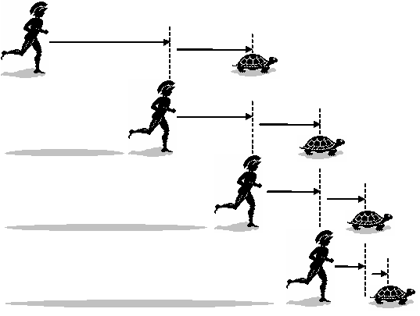

A famous paradox is that of Achilles and the Tortoise, in which Achilles (a Greek hero who can run fast) is challenged by the Tortoise (very slow) to a race. Read the excerpt below about the paradox and answer the the below questions:

“Achilles allows the tortoise a head start of 100 meters. Suppose that each racer starts running at some constant speed, one faster than the other. After some finite time, Achilles will have run 100 meters, bringing him to the tortoise's starting point. During this time, the tortoise has run a much shorter distance, say 2 meters. It will then take Achilles some further time to run that distance, by which time the tortoise will have advanced farther; and then more time still to reach this third point, while the tortoise moves ahead. Thus, whenever Achilles arrives somewhere the tortoise has been, he still has some distance to go before he can even reach the tortoise.”

1. Explain what is meant by a paradox (2)
2. How is the situation narrated of the race between Achilles and the Tortoise a mathematical paradox? (3)

Q2. An entrepreneur wants to start a company that will create software that will ensure that confidential data can remain protected from unauthorised access. What kind of mathematical expert should the entrepreneur bring on board her company to help develop the software?

1. Cryptographer
2. Topologist
3. Logician
4. Computer simulations expert

Q3. A scientist has a theory about how the positions of stars in the universe used to be a billion years ago. She has access to lots of data about how the positions of stars in the universe we can observe have changed their positions over the last century. What mathematical approach would likely work best for investigating her theory?

1. Running a computer simulation that uses the currently available data about stars and uses it to project their positions in the past
2. Creating an equation with each of the stars of the universe as separate variables and then solving it manually
3. Formulating a mathematical proof by contradiction that the stars could only have been in a flat plane of of surface area 100,000,000 km2 a billion years ago
4. Running a computer simulation that uses the currently available data of any single star and uses it to project its position in the past

## Appendix

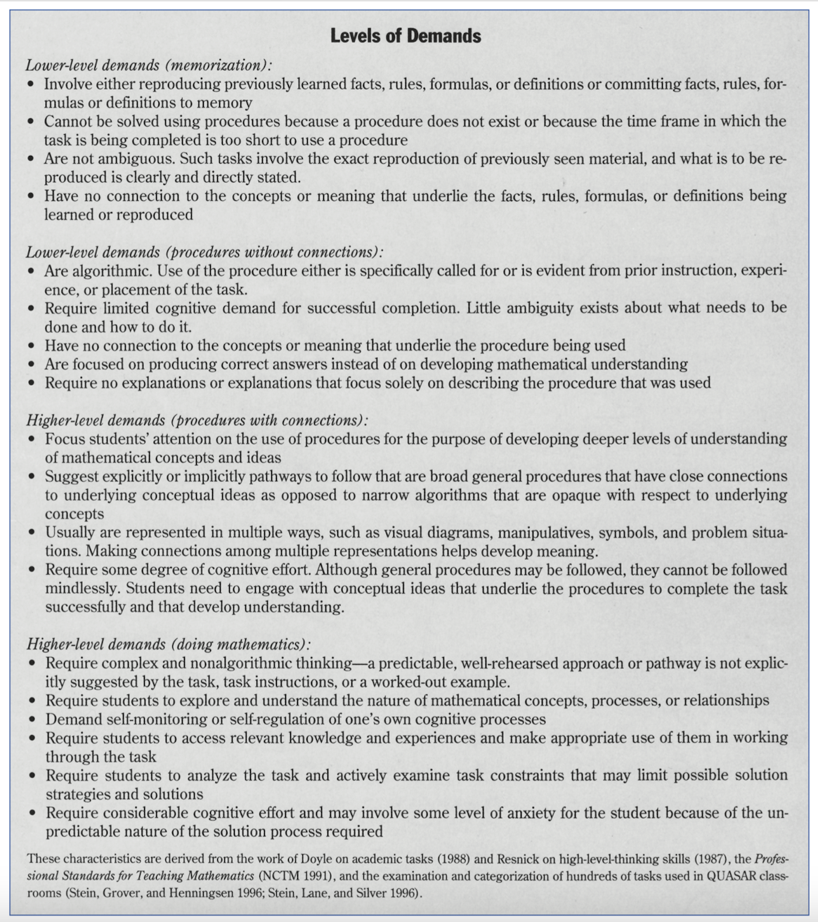

In NCTM (2015) from Smith and Stein (1998)

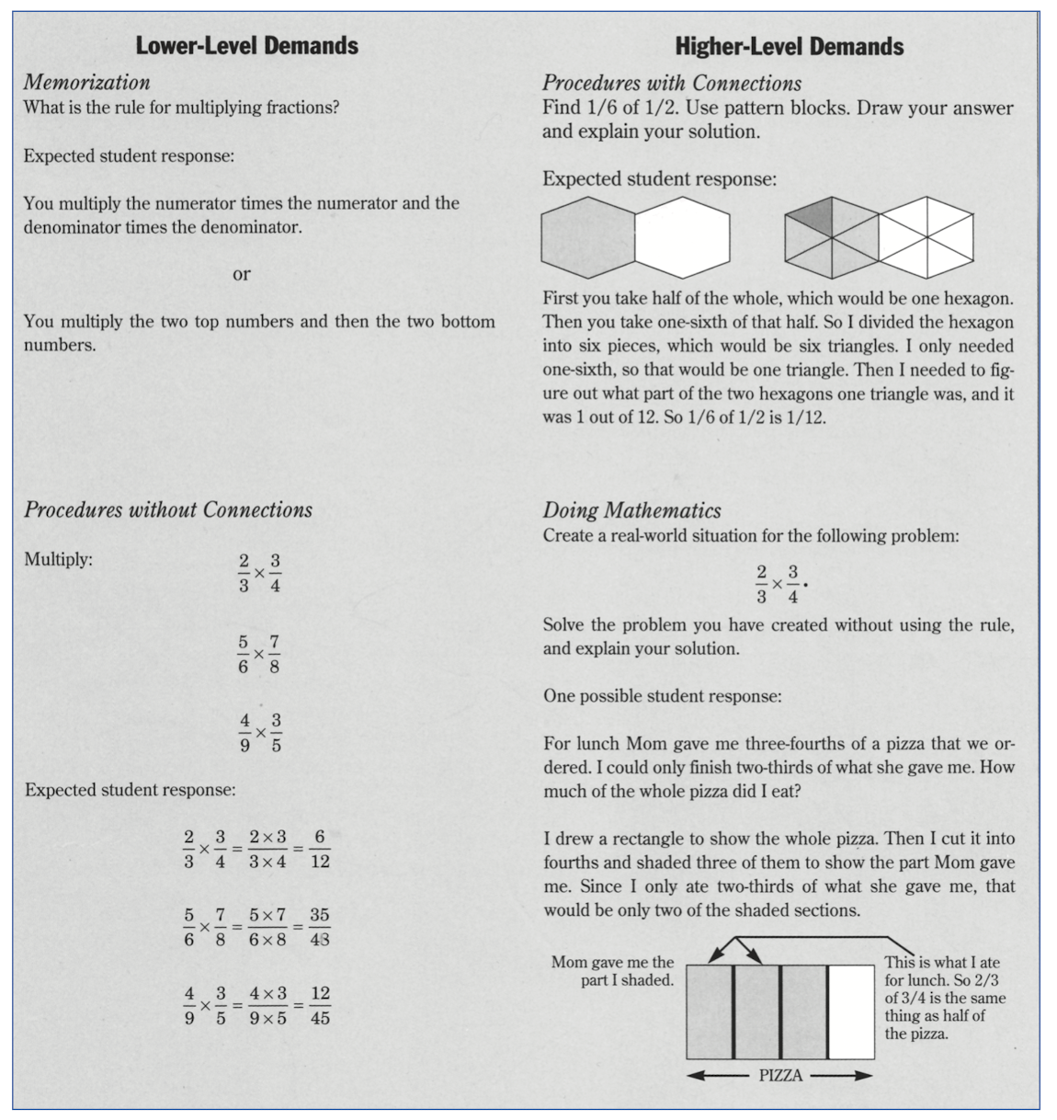

In NCTM (2015) from Smith and Stein (1998)

**Sample task and rubric:**

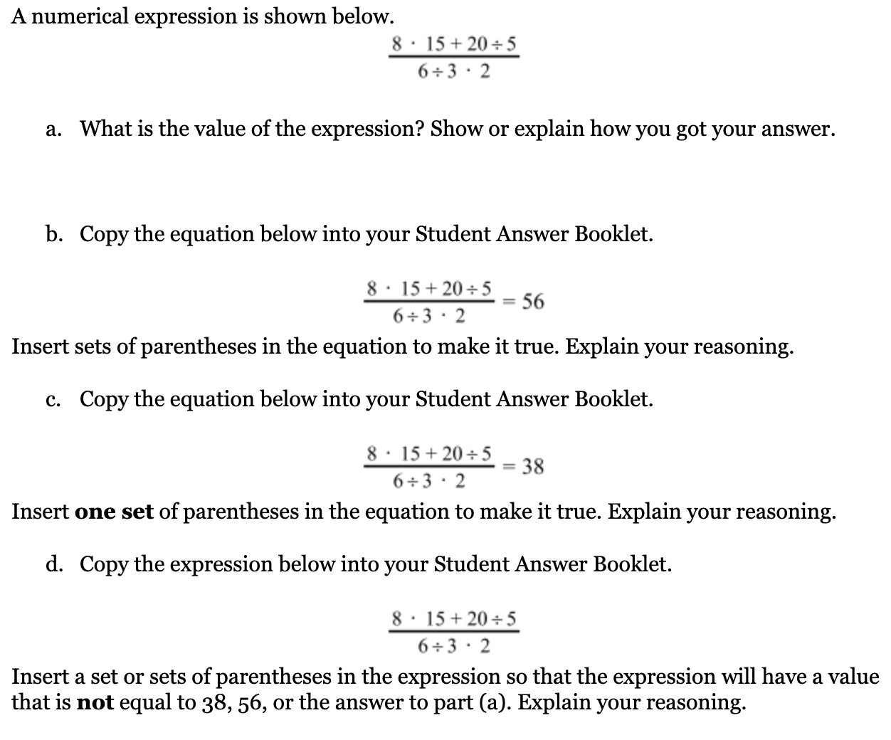

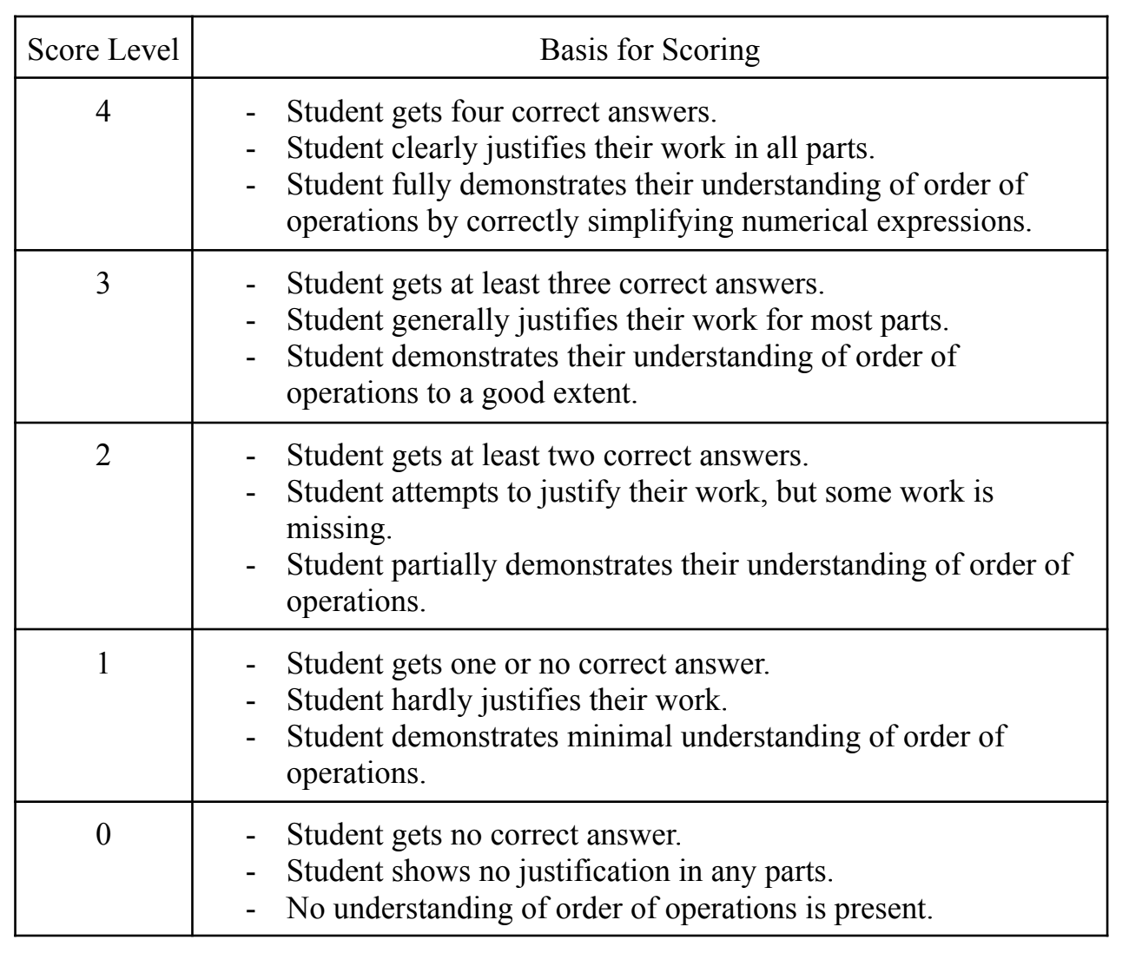

## References

Boaler, J. (2015). *What's math got to do with it?: How teachers and parents can transform mathematics learning and inspire success*. Penguin.

Grouws, D. A. (2003). The teacher’s role in teaching mathematics through problem solving. *Teaching mathematics through problem solving: Grades*, 6-12.

Leatham, K. R., Lawrence, K., & Mewborn, D. S. (2005). Getting started with open-ended assessment. *Teaching Children Mathematics*, *11*(8), 413-419.

McGatha, M. B., & Darcy, P. (2010). Rubrics at play: Reflect and discuss. *Mathematics Teaching in the Middle School*, *15*(6), 328-336.

National Council of Teachers of Mathematics (NCTM). (2014). Principles to actions: Ensuring mathematical success for all. National Council of Teachers of Mathematics.